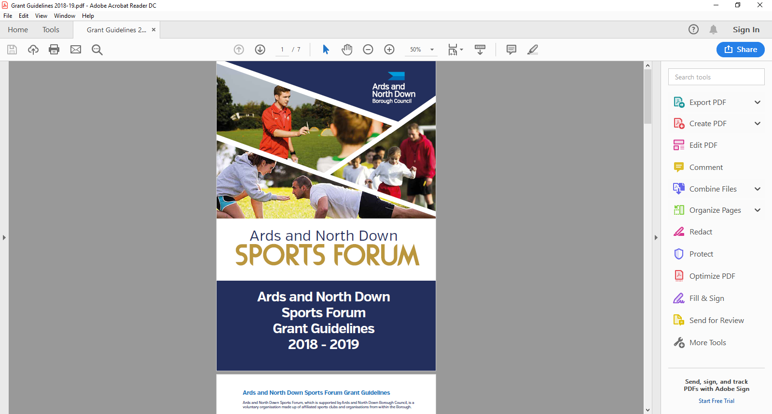

2025 - 2026

Sports Equipment

Application Form

**Aim of Grant:**

The aim of the grant is to provide financial assistance to support sports club to create new opportunities, increase and/or sustain participation within the club.

**Funding allocation:**

Ards and North Down Sports Forum have allocated £22,000 for 2025/26. Maximum funding per sporting organisation is **£1,500 (per financial year)**, a max of £500 can be allocated for fundamental equipment. This is subject to available funds. Should the programme be oversubscribed and due to limited funds available, a reduction in funding percentage will be applied to pending applications at that time.

**Application Timeline**

Event grants will be open in 2 tranches.

|  |  |
| --- | --- |
| **Tranche 1** | **£5,000** |
| **OPEN** Monday 19th May at 12noon and **CLOSE** at 12noon on Tuesday 17th June 2025 | |
| Assessment will be week commencing Monday 23th June 2025 | |
| Notification to sports clubs will be week commencing Monday 30th June 2025 | |
| **Please note**: if there is any underspend in Tranche 1 funds will roll into Tranche 2. | |

|  |  |
| --- | --- |
| **Tranche 2** | **£5,000** |
| **OPEN** Monday 25th August at 12noon and **CLOSE** on 12noon Tuesday 23rd September 2025 | |
| Assessment will be week commencing Monday 29th September 2025 | |
| Notification to sports clubs will be Monday 6th October 2025 | |
| **Please note**: Following grant assessment and allocations and if there is funding remaining, Council may consider awarding grants of more than £1,500 should the need be identified and in merit order. | |

**Applicant Eligibility:**

To be eligible to apply, applicants must meet the following eligibility requirements:

* Affiliated to the Ards and North Down Sports Forum
* Delivering sporting activities within Ards and North Down
* Have a constitution or Memorandum of Association
* Have a Safeguarding Children and/or Vulnerable Adult Policy
* Have an Equality Policy
* Have adequate Public Liability Insurance.
* Proof of permission to store equipment on property/ in facility.

**ONLY APPLICATIONS COMPLETED IN A TYPED FORMAT CAN BE ACCEPTED.**

**Section 1 - Organisational Details**

|  |  |
| --- | --- |
| Name of Club/ Organisation |  |
| Sport |  |
| Governing Body |  |
| Contact Name |  |
| Role/Position within Club/ Organisation |  |
| Address for correspondence |  |
| Contact telephone number |  |
| Contact Email |  |
| Ards and North Down Sports Forum 2025/26 Reference number |  |

**Section 2 – Equipment /Criteria**

|  |  |  |  |  |
| --- | --- | --- | --- | --- |
| Please tick what the equipment will be used for? (**one application per category ticked**) | Enhance physical literacy for Junior sections. | |  | |
| Support the development of new sections. | |  | |
| Equipment to help host events. | |  | |
| Training equipment. | |  | |
| Recovery sport Equipment. | |  | |
| High performance equipment. | |  | |
| Outline equipment to be sourced |  | | | |
| Where will the equipment be stored? |  | | | |
| Do you have permission to store this equipment?  **If ‘YES’ please include evidence of permission** | YES | NO | | NA (Stored in clubs own premises) |

Please demonstrate how your project addresses the criteria below. **Please use SMART principles (Specific, Measurable, Achievable, Relevant, Time-framed) when answering the following questions. Please advise:**

|  |  |
| --- | --- |
| **Question 1**  Please demonstrate the need for the equipment and its purpose.  **(25 marks)** |  |
| **Question 2**  Please demonstrate how the equipment will benefit the sports club/members and local community.  **(25 marks)** |  |
| **Question 3**  Please demonstrate how the equipment will create new opportunities for people to take part in sport and/or physical recreation within the Borough  **(25 marks)** |  |
| **Question 4**  Please demonstrate how the sports equipment will improve and sustain participation within your club.  **(25 marks).** |  |
| **Total marks 100** |  |

**Section 3 - Funding Details**

**Fundamental Equipment**

A maximum of £500 towards Fundamental Equipment may be requested per financial year) e.g. balls, sticks/racquets, safety equipment.

|  |  |  |  |  |
| --- | --- | --- | --- | --- |
| Project breakdown/Equipment itemised | Net Costs (excluding VAT) | VAT Costs | Total project costs | Amount requested from funding |
|  | £ | £ | £ | £ |
|  | £ | £ | £ | £ |
|  | £ | £ | £ | £ |
|  | £ | £ | £ | £ |
| **Total Costs** | **£** | **£** | **£** | **£** |

**Non-Fundamental Equipment**

|  |  |  |  |  |
| --- | --- | --- | --- | --- |
| Project breakdown/Equipment itemised | Net Costs (excluding VAT) | VAT Costs | Total project costs | Amount requested from funding |
|  | £ | £ | £ | £ |
|  | £ | £ | £ | £ |
|  | £ | £ | £ | £ |
|  | £ | £ | £ | £ |
|  |  |  |  |  |
| **Total Costs** | **£** | **£** | **£** | **£** |

|  |  |  |
| --- | --- | --- |
| Is your club/organisation VAT registered? | Yes | No |
| If yes, what is your VAT registration number? |  | |
| Does your club / organisation intend to claim VAT back if successful? | Yes | No |

**Section 4 – Any additional information**

Please provide any additional information which you feel is relevant to your application.

|  |
| --- |
|  |

**Section 5 – Mandatory Information Checklist**

Please ensure the following documents are attached to your application

**Failure to submit all the necessary documents in full, will result in your application not progressing (If in doubt please contact a member of the Sports Development team who will be happy to assist).**

|  |  |  |
| --- | --- | --- |
| **Document required** |  | **Attached** |
| Constitution or Memorandum of Association | **Essential** |  |
| Club/Organisation Safeguarding Children and/ or Vulnerable Adult Policy (must have been reviewed and signed & dated within the past 3 years) | **Essential** |  |
| *If a Club is adopting the National Governing Body Safeguarding Policy, the Club must provide written confirmation of this, and provide details of Designated Safeguarding Officers. | **Essential** |  |
| Equality Policy | **Essential** |  |
| Public Liability Insurance | **Essential** |  |
| Permission of Storage | **Essential** |  |

**Section 6 – Declaration**

This must be signed by the Chairperson of the organisation alongside another Club Member and dated accordingly.

|  |
| --- |
| I declare that the information provided is correct to the best of my knowledge.  I agree to promote equality and good relations in all our activities involving the use of Council funding in accordance with Section 75 of the Northern Ireland Act 1998.  I declare that I will complete a Grant Report Form and will acknowledge the funders in all publicity.  I declare that the Council will be notified immediately of any additional findings not declared in this application.  It is understood that monies will only be paid out on the production of all, receipts.  Any grant funding deemed ineligible or not spent will be re-payable to Ards and North Down Borough Council. |

|  |  |  |
| --- | --- | --- |
|  | | |
|  | Chairperson | Club Member (Position in Organisation) |
| Signed |  |  |
| Name  (Please print) |  |  |
| Date |  |  |

Once completed, please email the application along with the essential documentation to the following address: **[sportsdevelopment@ardsandnorthdown.gov.uk](mailto:sportsdevelopment@ardsandnorthdown.gov.uk)**

**DATA PROTECTION.**

Ards and North Down Borough Council is the data controller for the purposes of the Data Protection Act 2018 and the UK GDPR, which means it determines what your personal data is used for and why it is collected. We will only collect your data for the purposes of this application and retained for a period of up to 7years for financial reasons in line with Council’s retention and disposal policy.

We will not share your data with any third party unless it is required for legal reasons.

Your personal data is yours. You have the right to get copies of the information we hold about you.

If you want to request information regarding your data, please email: The Data Protection Officer: [dataprotection@ardsandnorthdown.gov.uk](mailto:dataprotection@ardsandnorthdown.gov.uk)

**FREEDOM OF INFORMATION.**

Under the Freedom of Information Act 2000 (FOIA), individuals have a right to request access to the information held by a public body. This can include grant applications.

Under the FOIA we are not obliged to release the personal information of individuals unless they consent to this release.

Consequently, Ards and North Down Borough Council will not disclose sensitive personal data to anyone else without the individuals express consent. Additionally, we will seek permission from the individual or organisation who submitted the application for their views about its release in the event of a request for this information.

**What do you do if you are unhappy with how we have handled your information?**

It is also your right to complain about our use of your data to the Information Commissioners Office, who are our regulator, but please contact us first to try and resolve any issues.

[Access the full privacy notice here.](https://www.ardsandnorthdown.gov.uk/privacy-and-cookies)