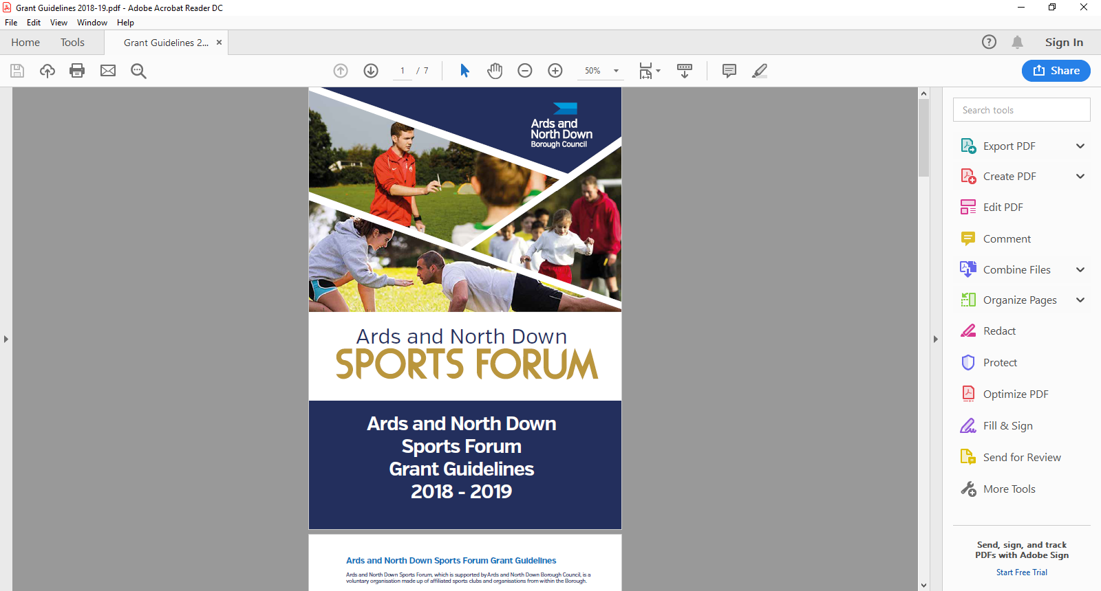

2025-2026

Seeding

Application Form

**Seeding Grant Applicant Eligibility**

Ards and North Down Sports Forum supports the development of new sports clubs and new sections of existing clubs.

To be eligible to apply, applicants must meet the following eligibility requirements.

* The club must be based within the Borough of Ards and North Down.
* The club must be affiliated to the Ards and North Down Sports Forum for a minimum period of three months, before an application can be made for financial support.
* New clubs must have been established for a minimum period of three months and a maximum of one year.
* The club must have a constitution and/or set of rules, signed and dated.
* List of Office bearers within club
* The club must have a UK club bank or building society account.
* Clubs who have junior sections must provide a safeguarding policy.
* New sports who are currently going through the Sport NI or Sport Ireland National Governing Body recognition process will be required to provide evidence of registration.

**Funding Limits**

Seeding grants up to £1,000 are available; £200 out of the £1,000 can be for promotional items

**Application Timeline**

Seeding grants are open all year round from 1 April 2025 – 24 February 2026. Applications are assessed monthly by the Ards and North Down Sports Forum.

|  |  |
| --- | --- |
| **Deadline for Receipt of Application Form** | **Assessment Date** |
| 25 March 2025 | 1 April 2025 |
| 29 April 2025 | 6 May 2025 |
| 27 May 2025 | 3 June 2025 |
| 24 June 2025 | 1 July 2025 |
| 29 July 2025 | 5 August 2025 |
| 26 August 2025 | 2 September 2025 |
| 30 September 2025 | 8 October 2025 |
| 28 October 2025 | 4 November 2025 |
| 25 November 2025 | 2 December 2025 |
| 30 December 2025 | 6 January 2026 |
| 27 January 2026 | 5 February 2026 |
| 24 February 2026 | 3 March 2026 |

*Please refer to **guidance notes as incomplete application will not be accepted. Guidance Notes are available at the link below:**

<https://www.leisureardsandnorthdown.com/sports-development/funding>

Please submit applications to[**sportsdevelopment@ardsandnorthdown.gov.uk**](mailto:sportsdevelopment@ardsandnorthdown.gov.uk)

**Section 1 - Organisational Details**

|  |  |
| --- | --- |
| Name of Club/ Organisation |  |
| Sport |  |
| Governing Body |  |
| Contact Name |  |
| Role/Position within Club/ Organisation |  |
| Address for correspondence |  |
| Contact telephone number |  |
| Contact Email address |  |
| Ards and North Down Sports Forum Reference number 2025/26 |  |
| When did your club/ new section commence? |  |
| Detail reasons why club/ section established. |  |
| What will the seeding grant provide for? |  |
| How will the grant benefit the club and its members? |  |

**Section 2 – Funding Details**

Grants awarded up to a maximum of £1000.

|  |  |  |  |  |
| --- | --- | --- | --- | --- |
| Project breakdown | Net Costs  (excluding VAT) | VAT Costs | Total project costs | Amount requested from funding |
|  | £ | £ | £ | £ |
|  | £ | £ | £ | £ |
|  | £ | £ | £ | £ |
|  | £ | £ | £ | £ |
|  | £ | £ | £ | £ |
| **Total Costs** | **£** | **£** | **£** | **£** |

|  |  |  |
| --- | --- | --- |
| Is your club/organisation VAT registered? | Yes  VAT Number ________ | No |
| Does your club / organisation intend to claim VAT back if successful? | Yes | No |

**Section 3 – Document Checklist**

Please ensure the following documents are attached to your application.

|  |  |  |  |
| --- | --- | --- | --- |
| **Mandatory Documents required** |  | **Attached** | |
| Club Constitution/Set of Rules | **Essential** |  | |
| A copy of AGM minutes | **Essential** |  | |
| Most recent club bank statement | **Essential** |  | |
| Copy of Office Bearers, names and positions | **Essential** |  | |
| Safeguarding Children and/or Vulnerable Adults Policy (must have be signed & dated) | **Essential** |  | |
| **Please note:**  If a Club is adopting the National Governing Body Safeguarding Policy, the Club must provide written confirmation of this and provide details of Designated Safeguarding Officers. |  |  | |
|  | | |

**Incomplete applications, applications received without the accompanying mandatory supporting documentation, will be deemed ineligible and not proceed for assessment.**

**Section 5 – Declaration**

|  |
| --- |
| I declare that the information provided is correct to the best of my knowledge.  I agree to promote equality and good relations in all our activities involving the use of Council funding in accordance with Section 75 of the Northern Ireland Act 1998.  I declare that I will complete a Grant Report Form after my event and will acknowledge the funders in all publicity.  I declare that the Council will be notified immediately of any additional findings not declared in this application.  It is understood that monies will only be paid out on the production of all, receipts.  Any grant funding deemed ineligible or not spent will be re-payable to Ards and North Down Borough Council. |
| This must be signed by the Chairperson of the organisation alongside another Club Member and dated accordingly.   |  |  |  | | --- | --- | --- | | Signed | Chairperson | Club Member (Position in Organisation) | | Name  (Please print) |  |  | | Position in Organisation/Club |  |  | | Date |  |  | |

Once completed, please email the application along with the essential documentation to the following address:  [**sportsdevelopment@ardsandnorthdown.gov.uk**](mailto:sportsdevelopment@ardsandnorthdown.gov.uk)

**DATA PROTECTION.**

Ards and North Down Borough Council is the data controller for the purposes of the Data Protection Act 2018 and the UK GDPR, which means it determines what your personal data is used for and why it is collected. We will only collect your data for the purposes of this application and retained for a period of up to 7years for financialasons in line with Council’s retention and disposal policy.

We will not share your data with any third party unless it is required for legal reasons.

Your personal data is yours. You have the right to get copies of the information we hold about you.

If you want to request information regarding your data, please email: The Data Protection Officer: [dataprotection@ardsandnorthdown.gov.uk](mailto:dataprotection@ardsandnorthdown.gov.uk)

**FREEDOM OF INFORMATION**

Under the Freedom of Information Act 2000 (FOIA), individuals have a right to request access to the information held by a public body. This can include grant applications.

Under the FOIA we are not obliged to release the personal information of individuals unless they consent to this release.

Consequently, Ards and North Down Borough Council will not disclose sensitive personal data to anyone else without the individuals express consent. Additionally, we will seek permission from the individual or organisation who submitted the application for their views about its release in the event of a request for this information.

**What do you do if you are unhappy with how we have handled your information?**

It is also your right to complain about our use of your data to the Information Commissioners Office, who are our regulator, but please contact us first to try and resolve any issues.

[Access the full privacy notice here.](https://www.ardsandnorthdown.gov.uk/privacy-and-cookies)