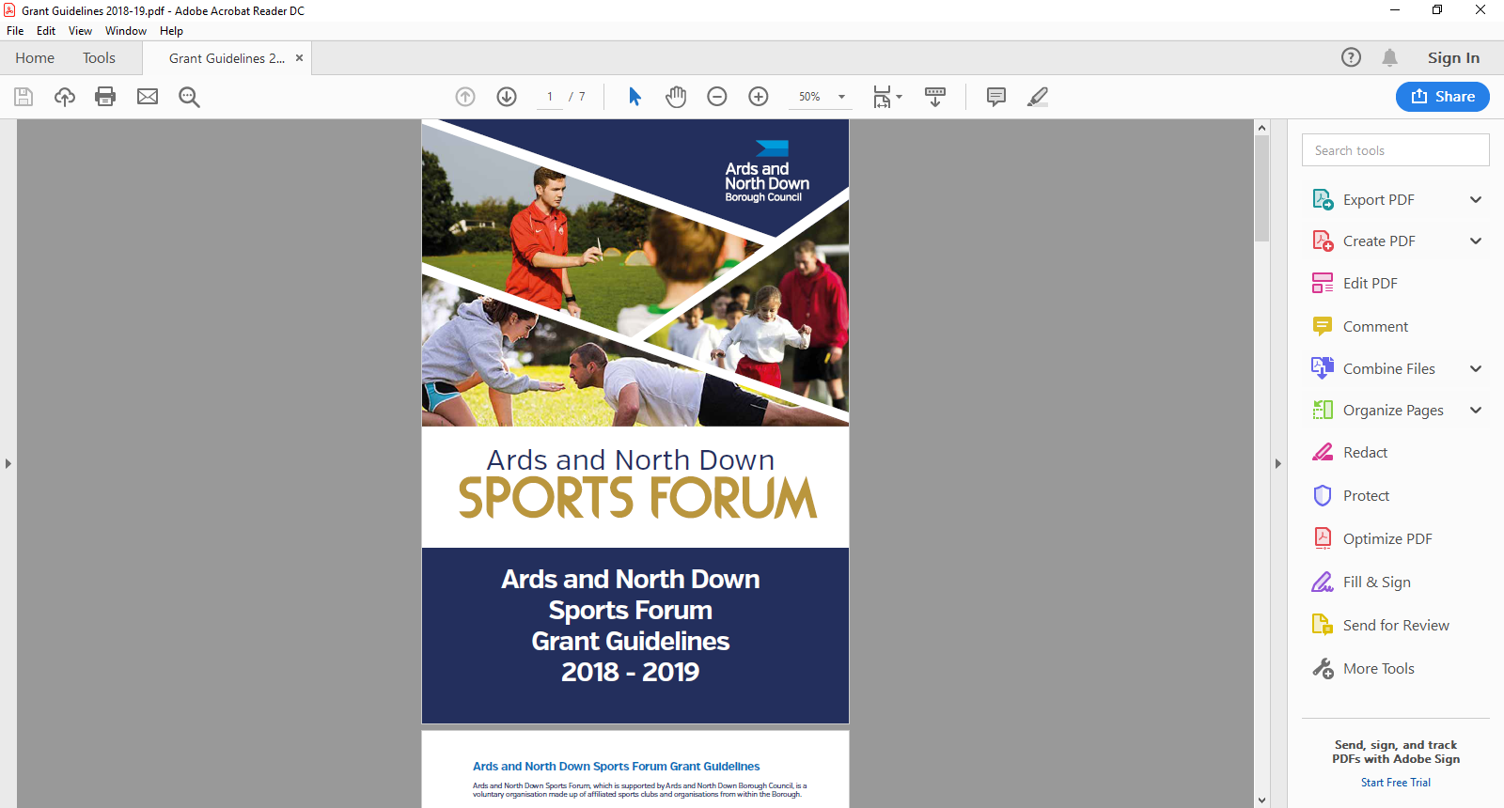

2025-2026

Goldcard

Application Form

Goldcards are open all year round from 1 April 2025 – 24 February 2026 and are assessed monthly by the Ards and North Down Sports Forum.

**Applicant Eligibility:**

* Applicants must be 12+ years, at the time of application.
* Be a resident in the Ards and North Down Borough Council area
* Take part in a Sport affiliated to a Governing Body recognised by Sport NI/Sport Ireland
* Be of amateur status
* Be a member of a recognised elite squad or be ranked within the top 10 in Northern Ireland / Ireland (Elite squad/panel e.g. Ulster, Northern Ireland, Ireland, Great Britain, European and above). This will cover Junior and Senior athletes and be inclusive of those with a disability.
* Be qualified and selected to represent their province/country (i.e. Ulster, N. Ireland, Ireland or Great Britain).
* Provide a letter/email from the relevant SNI/Sport Ireland Recognised National Governing Body* on official governing body paper or official governing body email statement. Please see link to recognised GB’s

**\***[**https://www.sportni.net/Recognition-List**](https://www.sportni.net/Recognition-List)

**\***[**https://www.sportireland.ie/Recognition-List**](https://www.sportireland.ie/Recognition-List)

* The letter/email must verify that you are part of a recognised squad or an Individual in preparation for a specific event/competition.
* The Governing Body letter/email **MUST** state what event/competition details you are preparing for and when the final squad will be announced, if applicable.
* The event/competition must be within 12 months of application being made.
* Not be in receipt of lottery or any other grant that would cover the facility element of training costs.

**The extent of use to be at the discretion of the Head of Leisure.**

**Restrictions**

Please note applicants should be aware that there are restrictions in place at each facility according to the individual site’s admissions policy, including:

* The Health Suite is for 16+ at Bangor Aurora and 8-15’s must be accompanied by an Adult at Ards Blair Mayne.
* There are ‘restrictions’ for use of the Gym for under 16’s and **inductions must be completed.**
* Swimming Pool restrictions apply
* Cryospa restrictions apply.

Please refer to **Guidance Notes** for a complete overview of grant guidelines, <https://www.leisureardsandnorthdown.com/sports-development/funding>

**ONLY APPLICATIONS COMPLETED IN A TYPED FORMAT CAN BE ACCEPTED.**

**Section 1 – Personal Details**

|  |  |
| --- | --- |
| Name |  |
| Date of Birth | *(Must be 12+ years at the time of application)* |
| Address | Postcode |
| Name for Correspondence | *(Please complete if different than applicant or applicant is under 18)* |
| Contact Email |  |
| Contact Number |  |

**Section 2 – Sport**

|  |  |
| --- | --- |
| Sport |  |
| Club |  |
| Recognised Governing Body | *(Please refer to links *)* |

**\***[**https://www.sportni.net/Recognition-List**](https://www.sportni.net/Recognition-List)

**\***[**https://www.sportireland.ie/Recognition-List**](https://www.sportireland.ie/Recognition-List)

|  |  |  |  |  |
| --- | --- | --- | --- | --- |
| **Which squad(s) are you currently training with** | | | | |
|  | Please tick | | Age/level e.g. Under 16, Senior Squad etc. | |
| Ulster |  | |  | |
| Northern Ireland |  | |  | |
| Ireland |  | |  | |
| Great Britain |  | |  | |
| Other (please specify) |  | |  | |
| **Please name the events you are training for within the next 12 months\*** | | | | | |
| Name of Event(s)* | | Date(s) | | Venue | |
|  | |  | |  | |
|  | |  | |  | |
|  | |  | |  | |
|  | |  | |  | |

**\***Only events listed on your Recognised National Governing Body selection letter/email will determine the duration of your Goldcard**.**

**Section 3 – Training Facilities**

|  |  |  |
| --- | --- | --- |
| **What training facilities do you wish to use?** | | |
| **Leisure Centre** | **Facility** | **Please tick** |
| Ards Blair Mayne Wellbeing & Leisure Complex | Gym |  |
| Health Suite |  |
| Pool |  |
| Bangor Aurora Aquatic and Leisure Complex | Gym |  |
| Health Suite |  |
| Pool |  |
| Bangor Sportsplex | Gym |  |
| Track |  |
| Comber Leisure Centre | Gym |  |
| Health Suite |  |
| Londonderry Park | Cryospa |  |
| Portaferry Sports Centre | Gym |  |
| Queen’s Leisure Centre (Holywood) | Gym |  |

**Section 4 – Funding**

|  |  |  |
| --- | --- | --- |
| Are you receiving funding assistance from any other source, for this financial year, towards the cost of training facilities? (Please tick) | | |
| Yes | No |  |
| If yes, please provide information below | | |
| Name of organisation/funding body providing assistance | Nature of Assistance  E.g. amount of funding, facility use | Duration of Assistance  E.g. one off payment, 3 year agreement |
|  |  |  |

**Section 5 – Document Checklist**

**Please ensure the following documents are attached to your application**

|  |  |
| --- | --- |
| **Mandatory Documents required** | **Attached (Please tick)** |
| Completed Application |  |
| Letter/Email of selection/qualification for event or squad selection, or top 10 ranking. |  |

**Section 6 – Declaration**

|  |
| --- |
| I declare to the best of my knowledge the information provided within this application is correct. I declare I am of amateur status and am a member of a recognised elite squad or am ranked within the Top 10 in Northern Ireland for my sport.  I declare that I will complete a Grant Report Form after my event and will acknowledge the funders in all publicity.  I declare that the Council will be notified immediately of any additional finding not declared in this application.  I am willing to support the Council, promote specific sports events/schemes during the lifespan of the Goldcard, if requested to do so. |

Signed: ___________________________ Date: ___________________

(to be signed by parent/guardian for applicant under 18 years)

Please email the application along with the required documentation to the following address: [**sportsdevelopment@ardsandnorthdown.gov.uk**](mailto:sportsdevelopment@ardsandnorthdown.gov.uk)

**Incomplete applications, and applications received without the accompanying mandatory supporting documentation, will be deemed ineligible and not proceed for assessment.**

**DATA PROTECTION**.

Ards and North Down Borough Council is the data controller for the purposes of the Data Protection Act 2018 and the UK GDPR, which means it determines what your personal data is used for and why it is collected. We will only collect your data for the purposes of this application and retained for a period of up to 7years for financial reasons in line with Council’s retention and disposal policy.

We will not share your data with any third party unless it is required for legal reasons.

Your personal data is yours. You have the right to get copies of the information we hold about you.

If you want to request information regarding your data, please email: The Data Protection Officer: [dataprotection@ardsandnorthdown.gov.uk](mailto:dataprotection@ardsandnorthdown.gov.uk?subject=HRC%20Booking%20System%20Query)

**FREEDOM OF INFORMATION.**

Under the Freedom of Information Act 2000 (FOIA), individuals have a right to request access to the information held by a public body. This can include grant applications.

Under the FOIA we are not obliged to release the personal information of individuals unless they consent to this release.

Consequently, Ards and North Down Borough Council will not disclose sensitive personal data to anyone else without the individuals express consent. Additionally, we will seek permission from the individual or organisation who submitted the application for their views about its release in the event of a request for this information.

**What do you do if you are unhappy with how we have handled your information?**

It is also your right to complain about our use of your data to the Information Commissioners Office, who are our regulator, but please contact us first to try and resolve any issues. [Access the full privacy notice here.](https://www.ardsandnorthdown.gov.uk/privacy-and-cookies)