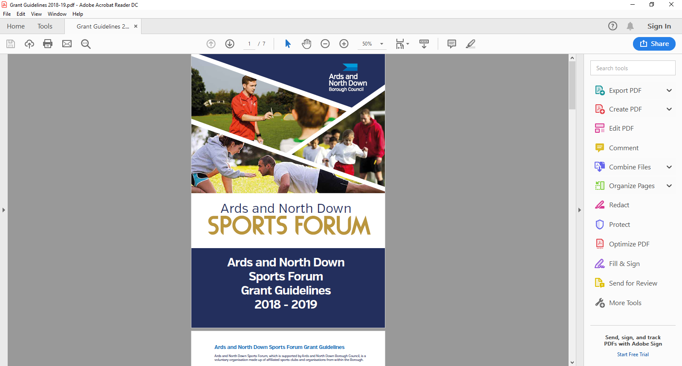

2025-2026

Events

Guidance Notes

**Aim of Grant**

The aim of the event grant is to provide financial assistance to support sport clubs in the delivery of safe, planned and organised events that encourage participation and/or competitive opportunities within the Borough of Ards and North Down

**Definition of an Event** – an activity that is planned for a special purpose and usually involves a lot of people, not the normal activities of the Club.

**Funding Allocation**

Ards and North Down Sports Forum have allocated £10,000 for 2025/26. Maximum funding per sporting organisation is **£1,500 (per financial year)**, a max of £500 can be allocated for fundamental equipment. This is subject to available funds. Should the programme be oversubscribed and due to limited funds available, a reduction in funding percentage will be applied to pending applications at that time.

**Application Timeline**

Event grants will be open in 2 tranches.

|  |  |
| --- | --- |
| **Tranche 1** | **£5,000** |
| **OPEN** Monday 19th May at 12noon and **CLOSE** at 12noon on Tuesday 17th June 2025 | |
| Assessment will be week commencing Monday 23th June 2025 | |
| Notification to sports clubs will be week commencing Monday 30th June 2025 | |
| **Please note**: if there is any underspend in Tranche 1 funds will roll into Tranche 2. | |

|  |  |
| --- | --- |
| **Tranche 2** | **£5,000** |
| **OPEN** Monday 25th August at 12noon and **CLOSE** on 12noon Tuesday 23rd September 2025 | |
| Assessment will be week commencing Monday 29th September 2025 | |
| Notification to sports clubs will be Monday 6th October 2025 | |
| **Please note**: Following grant assessment and allocations and if there is funding remaining, Council may consider awarding grants of more than £1,500 should the need be identified and in merit order. | |

**Eligibility Criteria**

To be eligible to apply, applicants must meet the following eligibility requirements.

* Be affiliated to the Ards and North Down Sports Forum
* Event must be delivered within the Borough of Ards and North Down
* Have a Formal Constitution
* Have a Safeguarding Children and/or Vulnerable Adult Policy
* Have an Equality Policy
* Have adequate Public Liability Insurance
* Submit an Event Risk Assessment

**Project Criteria**

Applicants must be able to demonstrate within the application how the event meets the following criteria. Please use SMART principles (Specific, Measurable, Achievable, Relevant, Time-framed) when answering the following questions.

1. Provide details on your sporting event and demonstrate how the event will increase participation.
2. Demonstrate the need for the event, how it benefits the sport club and the local community.
3. Provide approx. numbers participating the event – club members, volunteers and visitors/entries traveling to the Borough.
4. Demonstrate how the event will improve and sustain activities within the club
5. Does your event target any priority groups (women, disability, over 50’s and social disadvantaged areas/groups.

**Scoring Matrix**

|  |  |  |
| --- | --- | --- |
| **Assessment Criteria** | **Scoring** | **Success Factors** |
| **Criteria 1:**  Details of your event and how it will increase  participation | 10 Marks | The project provides the: who/what/when  The project describes how it will increase participation.  The project appears to have been well planned. |
| **Criteria 2:**  demonstrated the need for the event, how it benefits the sport club and the local community. | 15 marks | The project is clear and unambiguous.  The project provides clear outcomes that will benefit the club/ wider community. The project covers the: What, When, Where, How and Who |
| **Criteria** **3:**  Provided approx participation numbers for the event including Club members/ volunteers and those who have travelled from outside the Borough to take part in the event. | 25 Marks | The project appears to have been well planned/ provided attendance figures and partners. |
| **Criteria 4:**  Demonstrated how the event will improve and sustain activities within the club. | 25 marks | The project provides information of the how/ what and why and clear outcomes |
| **Criteria 5:**  Does your event target any priority groups (women, disability, over 50’s and social disadvantaged areas/groups. | 25 Marks | The project has identified a gap/need.  The project has clearly demonstrated the: How, Who & What  The project has the potential to bring about change. |
|  | **100 Marks** |  |

**A quality scoring threshold of 50 will be applied. Any application that fails to meet the above threshold will not be considered for funding.**

**For guidance and useful links on event management, please refer to Councils’ Event Management Toolkit:**

[Event Management Toolkit - Ards and North Down Borough Council](https://www.ardsandnorthdown.gov.uk/business/event-management-toolkit)

**The Event Management Toolkit includes:**

* **How to Manage your Event Guide**
* **Event Management Plan – Template and Guidance Notes**
* **Risk Assessment Template**
* **A request to use Council Land Form; please seek permission if you are using Council Land for your Event.**

**General Guidelines for Applicants**

Applications will be considered in line with the guidance outlined below:

* All applications must be completed in full, signed and submitted with all mandatory supporting information. Incomplete applications will not be considered, and **only typed forms** will be accepted.
* Sports Clubs/Organisations must be currentlyaffiliated to the Ards and North Down Sports Forum
* Retrospective funding will not be considered.
* Successful applicants must:
* Agree any changes to the project applied for and its funding arrangements with the Sports Forum before implementation.
* Notify the Sports Forum of any additional funding secured after submission of the application.
* Submit a completed grant report form with receipts and bank statements to the Ards and North Down Sports Forum by the deadline stated on their Letter of Offer. Failure to meet this deadline may result in funding being withdrawn.
* Please note that successful Clubs may be requested by the Council to acknowledge the Forum support in hosting their event.

**What we WILL Fund**

* Eligible Event Hire costs
* Sports Equipment to support the hosting of sports events within the Borough
* Fundamental equipment associated with any given sport such as balls, bats, racquets, sticks etc up to a max of £500, and will be subject to the discretion of the Sports Forum.
* External Coaches
* Event specific costs – Road Closures, External First Aid provision etc

**What we will NOT fund:**

* Projects, events, activities undertaken or equipment purchased outside of the specified award period.
* Projects, events, and activities where the primary benefits outside of the Borough.
* Events, projects or activities which conflict with any Council run project, event or activity.
* Organisations not legally established in the UK
* Projects, events, activities not compliant with the Council’s aims and objectives
* Sports or projects for sports not listed by Sport Northern Ireland / Sport Ireland
* Sports or projects which are discriminating
* Organisations that do not have a Safeguarding Children and Vulnerable Adults policy
* Retrospective funding or costs that will be incurred after the receipts deadline
* Costs incurred before successful Letter of Offer issued
* Activities promoting religious or political beliefs
* We will **NOT** fund profit making events (i.e. Income MUST go back into club)
* Insurance for public liability or personal injury
* Routine running costs
* Salary costs, loan repayments and endowments and volunteer costs
* Entertainment costs, food and beverages
* Alcoholic beverages
* Donations/fundraising events or activities.
* Organisation’s own facility hire – groups cannot be paid for use of own venue
* Office equipment, furniture, maintenance equipment and maintenance costs.
* Items which only benefit individuals (e.g. prizes; personal clothing or equipment; event tickets, water bottles etc)
* VAT that can be recovered from HM Revenue and Customs
* Publications, marketing
* Strategic planning/development e.g. consultancy fees
* Curriculum time school programmes.

**The list above is not exhaustive. The Council reserves the right to fund/not fund any project which is deemed suitable/unsuitable for the Ards and North Down Sports Forum grant scheme.**

**Incomplete applications, and applications received without the accompanying mandatory supporting documentation, will be deemed ineligible and not proceed for assessment.**

**Post Application Process**

Following submission of applications, the following process will be completed:

**Mandatory Information Check**

**Application**

**Acknowledged**

All applications received will be acknowledged by email, within five working days of receiving.

Applications that fail to submit all required information will not proceed to the next stage.

Applications considered in line with applicant eligibility/criteria.

**Sports Forum Assessment**

**Consideration of Application**

Applicants will be informed about the outcome, following the Sports Forum Assessment.

**Notification of Award Decision**

**Submit your applications: Completed applications are to be submitted by email to** [**sportsdevelopment@ardsandnorthdown.gov.uk**](mailto:sportsdevelopment@ardsandnorthdown.gov.uk)

**Further information**

Event guidance notes and application forms are available at:

[Grants and Funding | AND Leisure (leisureardsandnorthdown.com)](https://eur01.safelinks.protection.outlook.com/?url=https%3A%2F%2Fwww.leisureardsandnorthdown.com%2Fsports-development%2Ffunding&data=05%7C01%7CChristine.Cooke%40ardsandnorthdown.gov.uk%7C20013338fac84358cd2c08db8eb5f28a%7C39416dee5c8e4f5cb59d05c4bd0dd472%7C0%7C0%7C638260684472085308%7CUnknown%7CTWFpbGZsb3d8eyJWIjoiMC4wLjAwMDAiLCJQIjoiV2luMzIiLCJBTiI6Ik1haWwiLCJXVCI6Mn0%3D%7C3000%7C%7C%7C&sdata=Udzx8Hm%2FNVmiv20dVccVfCjhvj0UoUbmEkUPz6D4Daw%3D&reserved=0)

**For queries contact the Sports Development Team**

**Email:** [sportsdeveloment@ardsandnorthdown.gov.uk](mailto:sportsdeveloment@ardsandnorthdown.gov.uk)

**Emma Wightman**, Assistant Sports and Recreation Development Officer

Tel: 0300 013 3333 ext. 40253 / 07972 660301