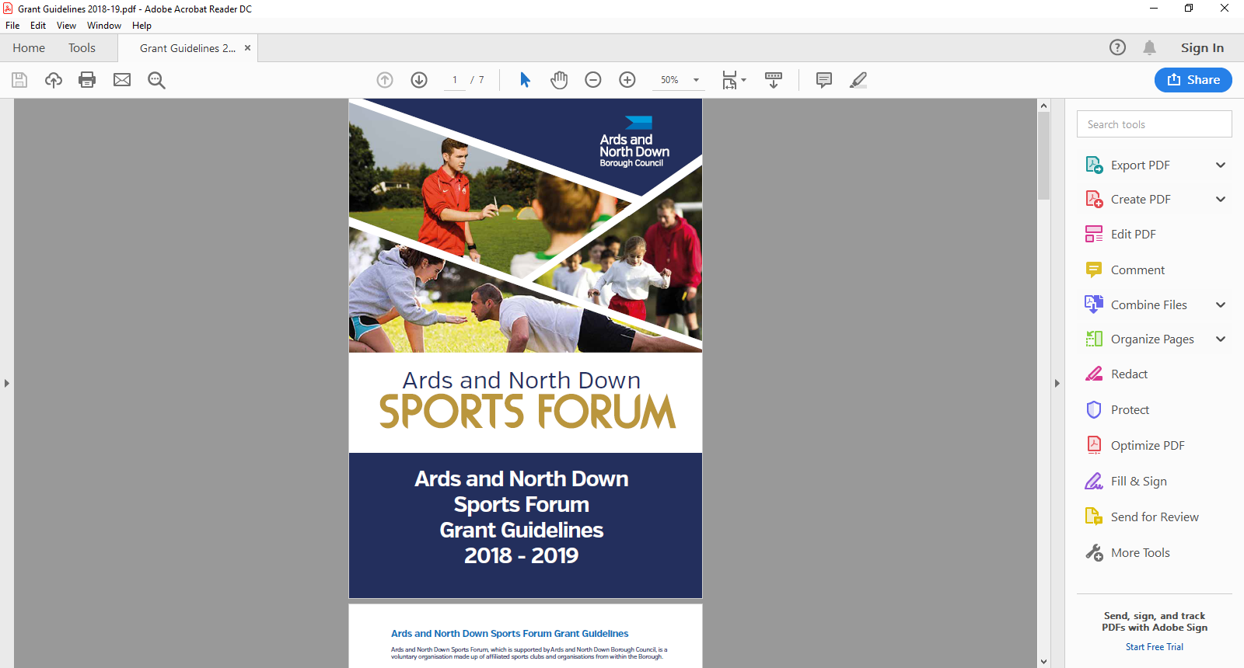

2025-2026

Anniversary

Guidance Notes

**Aim of Anniversary Grants**

Ards and North Down Sports Forum recognise ****

**Applicant Eligibility**

Financial assistance is available to sports clubs celebrating special anniversaries such as 15th, 25th 50th, 75th, 100th  etc

* The club request for a grant should be made **three months prior to the anniversary month being commemorated.**
* Only events such as tournaments, galas and special dinners will be considered.
* The club must be based in the Borough and be affiliated to the Ards and North Down Sports Forum.
* The club must provide a plan of how the grant would be spent and this should be submitted along with the request.

The Council expects clubs to undertake their own fundraising activities e.g. ticket sales to cover expenses and the Council will **ONLY** consider a grant contribution towards any shortfall in costs that arises.

**Funding Limits**

The maximum financial assistance awarded to clubs to assist with anniversaries is £750 **per financial year.**

Should the Programme be oversubscribed and due to limited funds available, a reduction in funding percentage will be applied to pending applications at that time.

**Application Timeline**

Anniversary grants are open all year round from 1 April 2025 – 24 February 2026. Applications are assessed monthly by the Ards and North Down Sports Forum.

|  |  |
| --- | --- |
| **Deadline for Receipt of Application Form** | **Assessment Date** |
| 25 March 2025 | 1 April 2025 |
| 29 April 2025 | 6 May 2025 |
| 27 May 2025 | 3 June 2025 |
| 24 June 2025 | 1 July 2025 |
| 29 July 2025 | 5 August 2025 |
| 26 August 2025 | 2 September 2025 |
| 30 September 2025 | 8 October 2025 |
| 28 October 2025 | 4 November 2025 |
| 25 November 2025 | 2 December 2025 |
| 30 December 2025 | 6 January 2026 |
| 27 January 2026 | 5 February 2026 |
| 24 February 2026 | 3 March 2026 |

*Please refer to **guidance notes as incomplete application will not be accepted. Guidance Notes are available at the link below:**

**General Guidelines for Applicants**

* All applications must be completed in full, signed and submitted with all mandatory supporting information. Incomplete applications will not be considered.
* Successful applicants must:
* Agree any changes to the project applied for and its funding arrangements with the Sports Forum before implementation.
* Notify the Sports Forum of any additional funding secured after submission of the application.
* Submit a completed report form with original receipts and original bank statements to the Ards and North Down Sports Forum, by the deadline stated on their Letter of Offer. Failure to meet this deadline may result in funding being withdrawn.

Please note that the Council decision making process, from the Sports Forum’s recommendations, may take up to eight weeks from date of assessment. This timeline must be taken into account along with the application/event timeline.

**What we will NOT fund:**

* Sports or projects for sports not listed by Sport Northern Ireland / Sport Ireland
* Sports or projects which are discriminating
* Organisations that do not have a Safeguarding Children and Vulnerable Adults policy
* Costs incurred before Application is submitted
* Retrospective funding or costs that will be incurred after the deadline for receipts - 4 weeks after Letter of Offer issued
* Activities promoting religious or political beliefs
* Insurance for public liability or personal injury
* Routine running costs
* Alcoholic beverages
* Donations/fundraising events or activities.
* Organisation’s own facility hire – groups cannot be paid for use of own venue
* Items which only benefit individuals e.g. prizes;
* VAT that can be recovered from HM Revenue and Customs
* Publications, marketing.

**The list above is not exhaustive. The Council reserves the right to fund/not fund any project which is deemed suitable/unsuitable for the Ards and North Down Sports Forum grant scheme.**

**For further information or any grant queries, please contact the Sports Development Team on:**

Emma Wightman, Assistant Sports and Recreation Development Officer

Tel: 0300 013 3333 ext. 40253

Emma Hingston, Sports and Recreation Development Officer

Tel: 0300 013 3333 ext. 40326 / 07920 187819

The Ards and North Down Sports Forum Grant Guidance Notes and Application Forms are available on: Ards and North Down Borough Council Website:

[Grants and Funding | AND Leisure (leisureardsandnorthdown.com)](https://eur01.safelinks.protection.outlook.com/?url=https%3A%2F%2Fwww.leisureardsandnorthdown.com%2Fsports-development%2Ffunding&data=05%7C01%7CChristine.Cooke%40ardsandnorthdown.gov.uk%7C20013338fac84358cd2c08db8eb5f28a%7C39416dee5c8e4f5cb59d05c4bd0dd472%7C0%7C0%7C638260684472085308%7CUnknown%7CTWFpbGZsb3d8eyJWIjoiMC4wLjAwMDAiLCJQIjoiV2luMzIiLCJBTiI6Ik1haWwiLCJXVCI6Mn0%3D%7C3000%7C%7C%7C&sdata=Udzx8Hm%2FNVmiv20dVccVfCjhvj0UoUbmEkUPz6D4Daw%3D&reserved=0)

or by emailing: [sportsdevelopment@ardsandnorthdown.gov.uk](mailto:sportsdevelopment@ardsandnorthdown.gov.uk)

**Post Application Process**

Following submission of applications, the following process will be completed:

**Notification of Award Decision**

**Post Deadline**

**Mandatory Information Check**

**Application**

**Acknowledged**

All applications received will be acknowledged by email, within five working days of receiving.

Applications that fail to submit all required information will not proceed to the next stage.

Applications that fail to meet the minimum eligibility requirements will not proceed to the next stage.

**Eligibility Check**

Applications considered in line with guidance above.

**Sports Forum Review**

**Consideration of Application**

**Approval Process**

**(Applications under £250)**

Sports Forum Panel recommendations (above £250) will be presented to the Community and Wellbeing Committee and Full Council for consideration/approval.

**Approval Process**

**(Applications over £250)**

Notification to applicants (above £250) will be issued following Council ratification.

Notification to applicants (below £250) will be issued following the Sports Forum review.

.