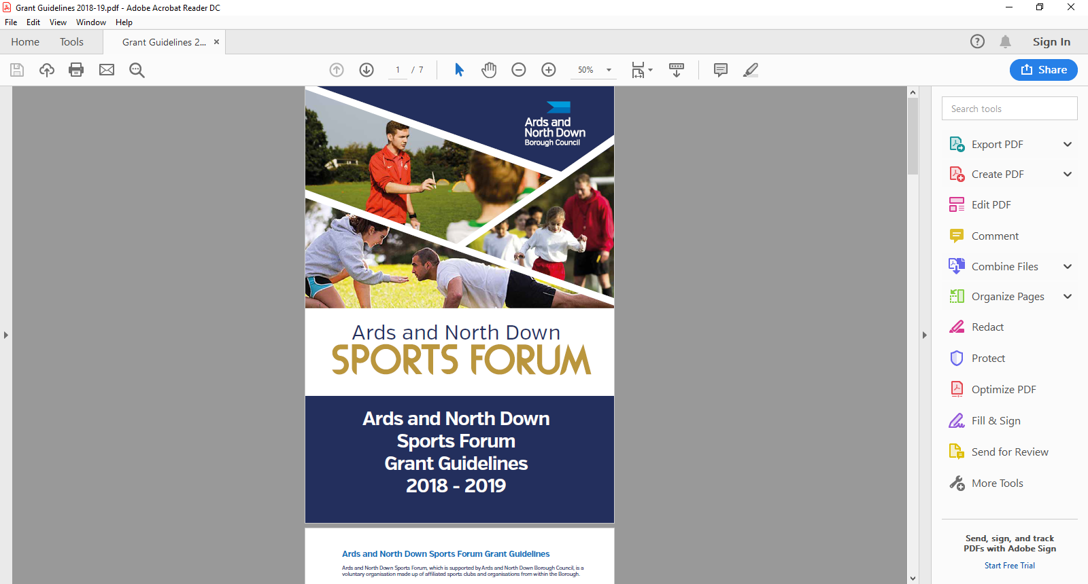

2025 - 2026

Anniversary

Application Form

Grant requests should be made **three months prior** to the Anniversary monthbeing commemorated.

**Section 1 - Organisational Details**

|  |  |
| --- | --- |
| Name of Club/ Organisation |  |
| Sport |  |
| Governing Body |  |
| Contact Name |  |
| Role/Position within Club/ Organisation |  |
| Address for correspondence |  |
| Contact telephone number |  |
| Contact Email address |  |
| Ards and North Down Sports Forum 2025/26 Reference number |  |

**Section 2 – Event Details**

|  |  |
| --- | --- |
| Name of Event |  |
| Date of Event |  |
| Anniversary being celebrated |  |
| Location of Event |  |
| Please briefly outline Event details, including anticipated numbers of participants. |  |
| What outcomes do you expect from the delivery of this Event? |  |
| Please outline any partnership approach, how and who will you be working with? |  |

**Section 3 - Funding Details**

Grants may be awarded towards a shortfall, up to a maximum of £750

|  |  |  |  |  |  |  |
| --- | --- | --- | --- | --- | --- | --- |
| Project breakdown | Net Costs  (excluding VAT) | VAT Costs | | Total project costs | | Amount requested from funding |
|  | £ | £ | | £ | | £ |
|  | £ | £ | | £ | | £ |
|  | £ | £ | | £ | | £ |
|  | £ | £ | | £ | | £ |
|  | £ | £ | | £ | | £ |
| **Total Costs** | **£** | **£** | | **£** | | **£** |
| Is your club/organisation VAT registered? | | | Yes | | No | |
| If yes, what is your VAT registration number? | | |  | | | |
| Does your club / organisation intend to claim VAT back if successful? | | | Yes | | No | |

**Section 4 – Any additional information**

Please provide any additional information which you feel is relevant to your application.

|  |
| --- |
|  |

**Section 5 – Document Checklist**

Please ensure the following documents are attached to your application

|  |  |  |
| --- | --- | --- |
| **Document required** |  | **Attached** |
| Club Constitution/Set of Rules | **Essential** |  |
| Most recent club/organisation bank statement | **Essential** |  |
| Copy of Office Bearers, names and positions | **Essential** |  |
| Event proposal/business plan | **Essential** |  |
| Full copy Safeguarding Children and/or Vulnerable Adults Policy | **Essential** |  |
| Copy of Public Liability Insurance | **Essential** |  |
| Copy of Club/Organisation Equality Policy | **Essential** |  |
| **Please note that all essential documents must be submitted with your application.** | | |

**Section 6 – Declaration**

This must be signed by the Chairperson of the organisation alongside another Club Member and dated accordingly.

|  |
| --- |
| I declare that the information provided is correct to the best of my knowledge.  I agree to promote equality and good relations in all our activities involving the use of Council funding in accordance with Section 75 of the Northern Ireland Act 1998.  I declare that I will complete a Grant Report Form and will acknowledge the funders in all publicity.  I declare that the Council will be notified immediately of any additional findings not declared in this application.  It is understood that monies will only be paid out on the production of all, receipts.  Any grant funding deemed ineligible or not spent will be re-payable to Ards and North Down Borough Council. |

|  |  |  |
| --- | --- | --- |
|  | **Chairperson** | **Club Member** (Position in Organisation) |
| Signed |  |  |
| Name  (Please print) |  |  |
| Date |  |  |

Once completed, please email the application along with the required documentation to the following address:

**sportsdevelopment@ardsandnorthdown.gov.uk**

**DATA PROTECTION.**

Ards and North Down Borough Council is the data controller for the purposes of the Data Protection Act 2018 and the UK GDPR, which means it determines what your personal data is used for and why it is collected. We will only collect your data for the purposes of this application and retained for a period of up to 7 years for financial reasons in line with Council’s retention and disposal policy.

We will not share your data with any third party unless it is required for legal reasons.

Your personal data is yours. You have the right to get copies of the information we hold about you.

If you want to request information regarding your data, please email: The Data Protection Officer: [dataprotection@ardsandnorthdown.gov.uk](mailto:dataprotection@ardsandnorthdown.gov.uk)

**FREEDOM OF INFORMATION.**

Under the Freedom of Information Act 2000 (FOIA), individuals have a right to request access to the information held by a public body. This can include grant applications.

Under the FOIA we are not obliged to release the personal information of individuals unless they consent to this release.

Consequently, Ards and North Down Borough Council will not disclose sensitive personal data to anyone else without the individuals express consent. Additionally, we will seek permission from the individual or organisation who submitted the application for their views about its release in the event of a request for this information.

**What do you do if you are unhappy with how we have handled your information?**

It is also your right to complain about our use of your data to the Information Commissioners Office, who are our regulator, but please contact us first to try and resolve any issues.

[Access the full privacy notice here.](https://www.ardsandnorthdown.gov.uk/privacy-and-cookies)