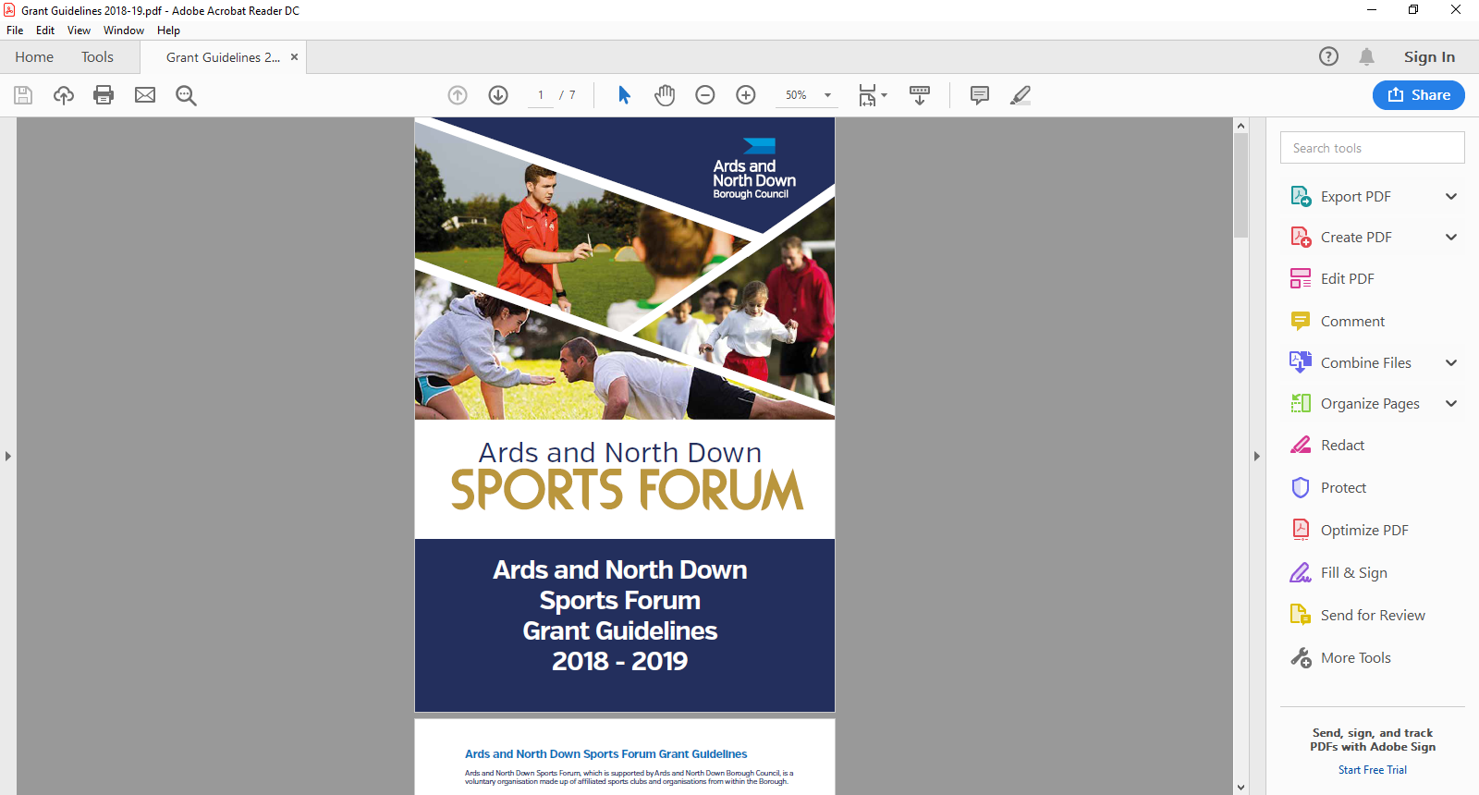

2025-2026

Seeding

Guidance Notes

**Aim of Grant**

The aim of the seeding grant is to support the development of newly established sports clubs and/or new sections of existing sports clubs.

**Funding**

Grants up to a maximum of £1000 will be available for new established sports clubs and/or new sections of existing sports clubs and can be used for the purchase of sports equipment and/or towards the cost of facility hire. Please note a maximum of £200 out of the £1,000 can be for promotional items. Examples of seeding grants

* New Women’s Section
* Disability Section
* New Youth Squad

**Please note: New club or section. excludes a new team within an existing section. For example, 3rd ladies’ team.**

**Funding Allocation**

Ards and North Down Sports Forum have allocated **£2,000;** the programme will remain open until the programme budget is fully exhausted. Should the programme be oversubscribed and due to limited funds available, a reduction in funding percentage will be applied to pending applications at that time.

**Application Process and Timeline**

Seeding grants are open all year round from 1 April 2025 – 24 February 2026. Applications are assessed monthly by the Ards and North Down Sports Forum.

All completed applications must be submitted prior to the deadline dates below along with essential documents. Submit completed applications to email: [**sportsdevelopment@ardsandnorthdown.gov.uk**](mailto:sportsdevelopment@ardsandnorthdown.gov.uk)

|  |  |
| --- | --- |
| **Deadline for Receipt of Application Form** | **Assessment Date** |
| 25 March 2025 | 1 April 2025 |
| 29 April 2025 | 6 May 2025 |
| 27 May 2025 | 3 June 2025 |
| 24 June 2025 | 1 July 2025 |
| 29 July 2025 | 5 August 2025 |
| 26 August 2025 | 2 September 2025 |
| 30 September 2025 | 8 October 2025 |
| 28 October 2025 | 4 November 2025 |
| 25 November 2025 | 2 December 2025 |
| 30 December 2025 | 6 January 2026 |
| 27 January 2026 | 5 February 2026 |
| 24 February 2026 | 3 March 2026 |

**Incomplete applications, and applications received without the accompanying mandatory supporting documentation, will be deemed as ineligible and not proceed for assessment.**

**Eligibility Criteria**

Applicants must meet the following eligibility requirements.

* The club must be based within the Borough of Ards and North Down.
* The club must be affiliated to the Ards and North Down Sports Forum for a minimum period of three months, before an application can be made for financial support.
* New clubs must have been established for a minimum period of three months and a maximum of one year.
* The club must have a constitution and/or set of rules, signed and dated.
* The club must have a club bank or building society account.
* Clubs who have junior sections must provide a safeguarding policy.
* New sports who are currently going through the Sport NI or Sport Ireland National Governing Body recognition process will be required to provide evidence of registration.

**Funding Limits**

Grants up to a maximum of £1000 will be available for new established sports clubs and/or new sections of existing sports clubs and can be used for the purchase of sports equipment and/or towards the cost of facility hire. Please note a maximum of £200 out of the £1,000 can be for promotional items. Examples of seeding grants

* New Women’s Section
* Disability Section``
* New Youth Squad

**Please note: New club or section. excludes a new team within an existing section. For example, 3rd ladies’ team.**

**General Guidelines for Applicants**

Applications will be considered in line with the guidance outlined below.

* All applications must be completed in full, signed and submitted with all the mandatory supporting information. Incomplete applications will not proceed for assessment, and only typed forms will be accepted.
* Changes to the expenditure or nature of the project **MUST** be approved by the Sports Development Officer before the Club proceeds.
* All expenditure must be within the financial year.
* Successful applicants will be provided with a ‘Letter of Offer’ and a specific deadline to return ‘Proof of Payment’ documents **(original receipts and club bank statement****). Failure to return documentation by the deadline will result in funding being withdrawn**

**What we will NOT fund:**

* Projects, events, activities undertaken or equipment purchased outside of the specified award period.
* Projects, events, and activities where the primary benefits outside of the Borough.
* Events, projects or activities which conflict with any Council run project, event or activity.
* Organisations not legally established in the UK
* Projects, events, activities not compliant with the Council’s aims and objectives
* Sports or projects for sports not listed by Sport Northern Ireland / Sport Ireland (should we remove)
* Sports or projects which are discriminating (not open to all sections of community)
* Personal equipment and clothing such as team kits and Items which only benefit individuals (e.g. prizes; scholarships; bursaries; water bottles)
* Costs incurred before successful Letter of Offer
* Activities promoting religious or political beliefs.
* Access NI registration fees
* Insurance for public liability or personal injury
* Affiliation, entry fees to competitions or membership fees
* Computer, software packages or websites (unless High Performance Analysis Equipment)
* Organisation’s own facility hire – groups cannot be paid for use of own venue
* Office equipment, furniture, maintenance equipment and maintenance costs.
* VAT that can be recovered from HM Revenue and Customs
* Publications, marketing
* Defibrillators
* Medical personal costs, e.g. physio, sports therapist, etc.
* Non-inclusive fitness initiative (IFI) gym equipment e.g. treadmills, rowers, bikes, etc.
* Retrospective funding

The list above is not exhaustive. The Council reserves the right to fund/not fund any project which is deemed suitable/unsuitable for the Ards and North Down Sports Forum grant scheme.

**Post Application Process**

Following submission of applications, the following process will be completed:

All applications received will be acknowledged by email, within five working days of receiving.

**Application**

**Acknowledged**

Applications that fail to submit all required information will not proceed to the next stage.

**Mandatory Information Check**

**Sports Forum Assessment**

Applications considered in line with applicant eligibility/criteria.

**Notification of Award Decision**

Applicants will be informed about the outcome, following the Sports Forum Assessment.

.

**Application forms**

Seeding grant guidance notes and applications are available at:

[Grants and Funding | AND Leisure (leisureardsandnorthdown.com)](https://eur01.safelinks.protection.outlook.com/?url=https%3A%2F%2Fwww.leisureardsandnorthdown.com%2Fsports-development%2Ffunding&data=05%7C01%7CChristine.Cooke%40ardsandnorthdown.gov.uk%7C20013338fac84358cd2c08db8eb5f28a%7C39416dee5c8e4f5cb59d05c4bd0dd472%7C0%7C0%7C638260684472085308%7CUnknown%7CTWFpbGZsb3d8eyJWIjoiMC4wLjAwMDAiLCJQIjoiV2luMzIiLCJBTiI6Ik1haWwiLCJXVCI6Mn0%3D%7C3000%7C%7C%7C&sdata=Udzx8Hm%2FNVmiv20dVccVfCjhvj0UoUbmEkUPz6D4Daw%3D&reserved=0) or by emailing [sportsdevelopment@ardsandnorthdown.gov.uk](mailto:sportsdevelopment@ardsandnorthdown.gov.uk)

**For queries contact the Sports Development Team.**

**Email:** [sportsdeveloment@ardsandnorthdown.gov.uk](mailto:sportsdeveloment@ardsandnorthdown.gov.uk)

**Emma Wightman**, Assistant Sports and Recreation Development Officer

Tel: 0300 013 3333 ext. 40253 / 07972 660301