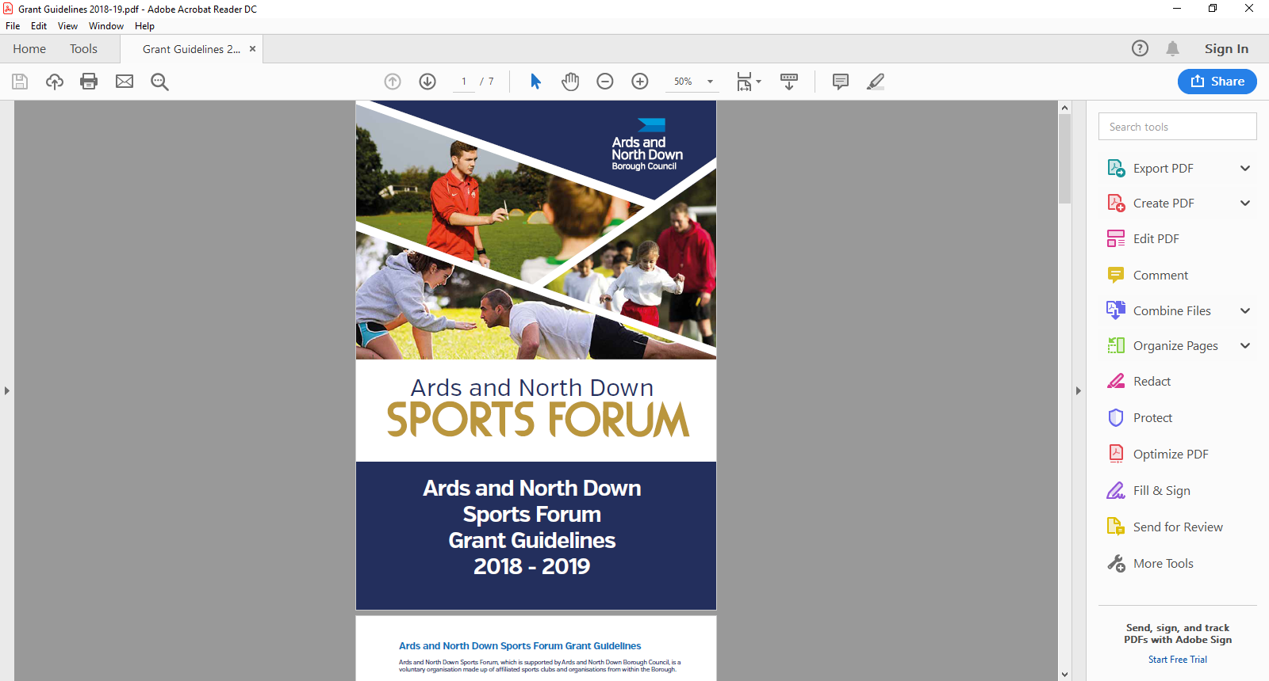

2025-2026

School/Sports Club Pathway

Application Form

**Applicant Eligibility**

To be eligible to apply, applicants must meet the following eligibility requirements.

Sports Clubs//Organisations MUST:

* Applications must be submitted **three months prior** to the programme commencing.
* Be affiliated to the Ards and North Down Sports Forum.
* Take part in a sport affiliated to a Governing Body recognised by Sport NI / Sport Ireland.
* Have a Safeguarding Children and/or Vulnerable Adult Policy.
* Have an Equality Policy.
* Have adequate public liability insurance (for coaches & venue).
* Submit a full programme Risk Assessment.

The Schools/Sports Club Pathway programme/sessions must:

* Be a new initiative.
* Be agreed with the school prior to submitting application.
* A School Teacher must be in attendance for the duration of the programme.
* The teacher attending the programme, must sign the application, prior to submission.
* Be delivered at venues within the Ards & North Down Borough
* Be delivered in accordance with programme Risk Assessment
* Be delivered by coach(es) who have:
  + Suitable Governing and/or Awarding Body qualifications.
  + Suitable Safeguarding training
  + Access NI Checked
  + Suitable Public Liability Insurance
  + At least one coach who has a valid First-Aid qualification.
* Meet the Governing Body Safeguarding ratios.
* Be a minimum of 6 sessions and maximum of 12 sessions in duration (final day of delivery must be prior to 31 March 2026)
* Schools must obtain parental consent, for pupils to attend the programme and keep an attendance register.

**Funding Limits**

A Schools/Sports Club Pathway Programme grant of up to a maximum of £500 per club (per financial year) is available, subject to available funding. A maximum of £300 of the £500 can be awarded towards fundamental equipment. Clubs may apply on more than one occasion but the maximum funding (per financial year) will be £500.

Should the Programme be over prescribed and due to limited funds available, a reduction in funding percentage will be applied to pending applications at that time.

*Please refer to **Guidance Notes** for a complete overview of grant guidelines, <https://www.leisureardsandnorthdown.com/sports-development/funding>

**ONLY APPLICATIONS COMPLETED IN A TYPED FORMAT CAN BE ACCEPTED.**

**Section 1 – Organisational / Applicant Details**

|  |  |
| --- | --- |
| Name of Club/ Organisation |  |
| Sport |  |
| Recognised Governing Body |  |
| Ards and North Down Sports Forum - Reference Number 2024/25 |  |
| **Your Details** |  |
| Contact Name |  |
| Role/Position within Club/ Organisation |  |
| Address for Correspondence |  |
| Contact telephone number |  |
| Contact Email address for correspondence |  |

**Section 2 – Schools/Sports Club Pathway Details**

|  |  |  |
| --- | --- | --- |
| Name of Programme |  | |
| Location of Programme |  | |
| Please outline your partnership approach, how and which school will you be working with. | **School:**  **Name of Teacher in Attendance:**  **Approach:** | |
| Target Group | **Age group:**  **Any further information:** | |
| Please outline Programme details, including anticipated numbers of participants.  NB Programmes must meet the Governing Body Safeguarding ratios. | **No. of Coach(es):** | **Anticipated no. of pupils:** |
| **Name of Coach(es)** | |
| **Further Programme Details:** | |
| Please demonstrate the need for the School/Sports Club Pathway Programme and how it will signpost pupils to further sports participation opportunities. |  | |
| Please detail the expected outcomes and impact of the programme on the sports club/organisation and wider community. |  | |

**Section 3 - Funding Details**

|  |  |  |  |  |
| --- | --- | --- | --- | --- |
| Project breakdown (Coaching costs, equipment costs, venue hire or transport costs). | Net Costs  (excluding VAT) | VAT Costs | Total project costs | Amount requested from funding |
|  | £ | £ | £ | £ |
|  | £ | £ | £ | £ |
|  | £ | £ | £ | £ |
|  | £ | £ | £ | £ |
|  | £ | £ | £ | £ |
| **Total Costs** | **£** | **£** | **£** | **£** |

|  |  |
| --- | --- |
| Where will the balance of funding come from, if total costs cannot be funded? |  |

|  |  |  |
| --- | --- | --- |
| Is your club/organisation VAT registered? | Yes | No |
| If yes, what is your VAT registration number? |  | |
| Does your club / organisation intend to claim VAT back if successful? | Yes | No |

**Section 3 – Any additional information**

Please provide any additional information which you feel is relevant to your application.

|  |
| --- |
|  |

**Section 4 – Document Checklist**

**Please ensure the following documents are attached to your application**

|  |  |  |  |
| --- | --- | --- | --- |
| **Documents required** |  | **Attached** | |
| Club/Organisation Constitution | **Essential** |  | |
| Copy of Public Liability Insurance | **Essential** |  | |
| Copy of Club/Organisation Equity Policy | **Essential** |  | |
| Club/Organisation Safeguarding Children and/or Vulnerable Adults Policy (must have been reviewed and signed & dated within the past 3 years) | **Essential** |  | |
| If a Club is adopting the National Governing Body Safeguarding Policy, the Club must provide written confirmation of this, and provide details of Designated Safeguarding Officers. | **Essential** |  | |
| Programme Risk Assessment (including Covid Mitigations) | **Essential** |  | |
| **Please note that all essential documents must be submitted with your application.** | | | |
|  | | |

**Section 5 – Declaration**

|  |  |  |
| --- | --- | --- |
| I declare that the information provided is correct to the best of my knowledge.  I agree to promote equality and good relations in all our activities involving the use of Council funding in accordance with Section 75 of the Northern Ireland Act 1998.  I declare that I will complete a Grant Report Form after my event and will acknowledge the funders in all publicity.  I declare that the Council will be notified immediately of any additional findings not declared in this application.  It is understood that monies will only be paid out on the production of all, receipts.  Any grant funding deemed ineligible or not spent will be re-payable to Ards and North Down Borough Council. | | |
| This must be signed by the Chairperson of the organisation/club alongside another Club Member and dated accordingly.  **The Club confirms that any Coach(es) delivering the programme have:**   * **Valid Coaching Qualifications** * **Valid Safeguarding Certificates** * **Valid Access NI Check** * **Public Liability Insurance (if applicable)** * **And at least one valid First Aid Certificate (a delivering Coach).** | | |
| Signed |  |  |
| Name  (Please Print) |  |  |
| Position in Organisation |  |  |
| Date |  |  |

This must be signed by the Teacher attending the Programme and dated accordingly.

**The School confirms that a teacher will be attending the programme and they will obtain parental consent for pupils to attend, keep an attendance register and adhere to GDPR legislation.**

|  |  |
| --- | --- |
| Signed |  |
| Name  (Please Print) |  |
| Position in School |  |
| Date |  |

Once completed, please send the application along with the required documentation to the following address:

**[sportsdevelopment@ardsandnorthdown.gov.uk](\\\\ardsandnorthdown.gov.uk\\Fileshare\\C&W\\Leisure and Amenities\\Leisure\\Sports Development\\Projects\\Funding - Funded Projects\\ANDBC Sports Forum\\Grant Scheme and Application Forms\\2024-2025\\DRAFT Application Forms\\sportsdevelopment@ardsandnorthdown.gov.uk)**

**ONLY APPLICATIONS COMPLETED IN A TYPED FORMAT CAN BE ACCEPTED.DATA PROTECTION**.

Ards and North Down Borough Council is the data controller for the purposes of the Data Protection Act 2018 and the UK GDPR, which means it determines what your personal data is used for and why it is collected. We will only collect your data for the purposes of this application and retained for a period of up to 7years for financial reasons in line with Council’s retention and disposal policy.

We will not share your data with any third party unless it is required for legal reasons.

Your personal data is yours. You have the right to get copies of the information we hold about you.

If you want to request information regarding your data, please email: The Data Protection Officer: [dataprotection@ardsandnorthdown.gov.uk](mailto:dataprotection@ardsandnorthdown.gov.uk?subject=HRC%20Booking%20System%20Query)

**FREEDOM OF INFORMATION.**

Under the Freedom of Information Act 2000 (FOIA), individuals have a right to request access to the information held by a public body. This can include grant applications.

Under the FOIA we are not obliged to release the personal information of individuals unless they consent to this release.

Consequently, Ards and North Down Borough Council will not disclose sensitive personal data to anyone else without the individuals express consent. Additionally, we will seek permission from the individual or organisation who submitted the application for their views about its release in the event of a request for this information.

**What do you do if you are unhappy with how we have handled your information?**

It is also your right to complain about our use of your data to the Information Commissioners Office, who are our regulator, but please contact us first to try and resolve any issues.

[Access the full privacy notice here.](https://www.ardsandnorthdown.gov.uk/privacy-and-cookies)