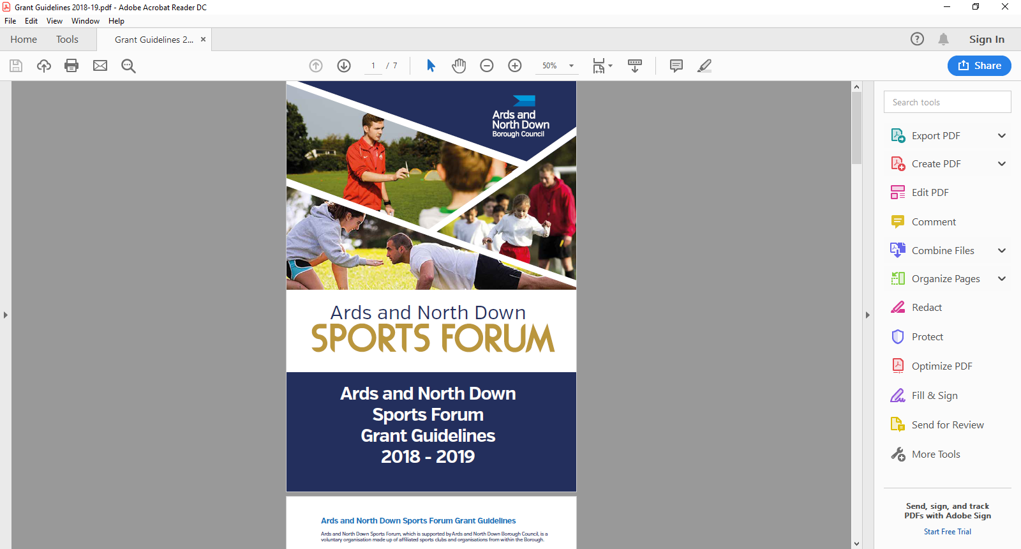

2025-2026

Schools/Sports Club Pathway

Guidance Notes

**Ards and North Down Sports Forum Grant Programme**

**Aim of Grant**

The aim of the school/sport club pathway is to encourage new partnerships between sport clubs and schools, to encourage young people to participate in sport and to create pathways for young people to sustain their involvement within sports clubs.

Affiliated clubs can apply for financial assistance towards the cost of delivering an after-school coaching programme and can avail of funding towards; equipment, venue hire and transport.

**Funding Limits**

A maximum of £500 per club (per financial year) is available, please note a maximum of £300 out of the £500 can be for fundamental equipment.

**Applications must be submitted three months prior to the programme commencing.**

**Funding Allocation**

Ards and North Down Sports Forum have allocated £2,000 for 20025/2026.

Should the programme be oversubscribed and due to limited funds available, a reduction in funding percentage will be applied to pending applications at that time.

**Application Timeline**

School/Sport Club pathway grants are open all year round from 1 April 2025 – 24 February 2026. Applications are assessed monthly by the Ards and North Down Sports Forum.

|  |  |
| --- | --- |
| **Deadline for Receipt of Application Form** | **Assessment Date** |
| 25 March 2025 | 1 April 2025 |
| 29 April 2025 | 6 May 2025 |
| 27 May 2025 | 3 June 2025 |
| 24 June 2025 | 1 July 2025 |
| 29 July 2025 | 5 August 2025 |
| 26 August 2025 | 2 September 2025 |
| 30 September 2025 | 8 October 2025 |
| 28 October 2025 | 4 November 2025 |
| 25 November 2025 | 2 December 2025 |
| 30 December 2025 | 6 January 2026 |
| 27 January 2026 | 5 February 2026 |
| 24 February 2026 | 3 March 2026 |

**Incomplete applications, and applications received without the accompanying mandatory supporting documentation, will be deemed as ineligible and not proceed for assessment.**

**Completed applications are to be submitted by email to** [**sportsdevelopment@ardsandnorthdown.gov.uk**](mailto:sportsdevelopment@ardsandnorthdown.gov.uk)

**An example of an eligible Project:**

A six-week Schools/Sports Club Pathway programme for Key Stage 2 (P4-7) from 3-4pm at the local leisure centre, followed by an Open Evening at the Club, to invite programme participants along to try the Club.

|  |  |  |  |  |
| --- | --- | --- | --- | --- |
| **Project breakdown (Coaching costs, equipment costs, venue hire or transport costs).** | **Net Costs**  **(excluding VAT)** | **VAT Costs** | **Total project costs** | **Amount requested from funding** |
| Coach Costs  6 weeks @ £25 per week x 1 Coach | £150 | £0 | £150 | £150 |
| Purchase of size balls for this age group  10 balls @ £5 each | £50 | £10 | £60 | £60 |
| Hire of Sports Hall for 6 weeks@ £40 per week | £240 | £48 | £288 | £288 |
| **Total Costs** |  |  |  | **£498.00** |

**Applicant Eligibility**

Applicants **must** meet the following eligibility requirements. Should an application be received that does not meet the minimum requirements below, the application will not proceed to the assessment stage of the process:

* Be affiliated to the Ards and North Down Sports Forum
* Take part in a sport affiliated to a Governing Body recognised by Sport NI / Sport Ireland.
* Have a Safeguarding Children and/or Vulnerable Adult Policy
* Have an Equality Policy
* Have adequate public liability insurance (for coaches & venue)
* Submit a full programme Risk Assessment.

**Project Criteria:**

* The programme must be a NEW partnership between the club and school, the applicant must demonstrate the need of the programme and the benefits to school/club.
* The applicant demonstrates HOW the programme will increase participation, build sustainable pathways between the club and school.
* Demonstrate how the club will signpost pupils to further sports participation opportunities e.g. a final session at the Club’s venue, invite participants and their families to an Open Night or help school obtain experience and qualifications for teachers.
* The programme must be a minimum of 6 sessions and maximum of 12 sessions in duration (final day of delivery must be prior to 31 March 2026)
* Be delivered at venues within the Ards & North Down Borough
* Engagement & approval must be sought by school prior to submission of application
* Applications must be submitted three months prior to the programme commencing.

**General Guidelines for Applicants**

Applications will be considered in line with the guidance outlined below.

* All applications must be completed in full, signed and submitted with all the mandatory supporting information. Incomplete applications will not proceed for assessment, and only typed forms will be accepted.
* Changes to the expenditure or nature of the project **MUST** be approved by the Sports Development Officer before the Club proceeds.
* All expenditure must be within the financial year.
* Successful applicants will be provided with a ‘Letter of Offer’ and a specific deadline to return ‘Proof of Payment’ documents **(original receipts and bank statement). Failure to return documentation by the deadline will result in funding being withdrawn**

**What we WILL Fund:**

* Specific Additional Equipment (fundamental equipment) associated with any given sport such as balls, bats, racquets, sticks etc up to a max of £300.
* Coaching costs
* Venue Hire (Except hire of own venue)
* School Travel Costs (to/from venue).

**What we will NOT fund:**

* Existing initiatives
* Curriculum time school programmes.
* Sports or projects for sports not listed by Sport Northern Ireland / Sport Ireland
* Organisations that do not have a Safeguarding Children and/or Vulnerable Adults Policy
* Retrospective funding or costs that will be incurred after the deadline for receipts.
* Costs incurred before successful Letter of Offer issued.
* Activities promoting religious or political beliefs.
* Access NI registration fees
* Items which only benefit individuals (e.g. prizes; personal clothing or equipment; water bottles, boots, kits etc.)
* VAT that can be recovered from HM Revenue and Customs
* Publications, marketing.
* Projects, events, activities undertaken or equipment purchased outside of the specified award period.
* Projects, events, and activities where the primary benefits outside of the Borough.
* Events, projects or activities which conflict with any Council run project, event or activity.
* Organisations not legally established in the UK
* Projects, events, activities not compliant with the Council’s aims and objectives.

**The list above is not exhaustive. The Council reserves the right to fund/not fund any project which is deemed suitable/unsuitable for the Ards and North Down Sports Forum grant scheme.**

**Post Application Process**

Following submission of applications, the following process will be completed:

All applications received will be acknowledged by email, within five working days of receiving.

**Application**

**Acknowledged**

Applications that fail to submit all required information will not proceed to the next stage.

**Mandatory Information Check**

**Sports Forum Assessment**

Applications considered in line with applicant eligibility/criteria.

**Notification of Award Decision**

Applicants will be informed about the outcome, following the Sports Forum Assessment.

.

**Application forms**

Seeding grant guidance notes and applications are available at:

[Grants and Funding | AND Leisure (leisureardsandnorthdown.com)](https://eur01.safelinks.protection.outlook.com/?url=https%3A%2F%2Fwww.leisureardsandnorthdown.com%2Fsports-development%2Ffunding&data=05%7C01%7CChristine.Cooke%40ardsandnorthdown.gov.uk%7C20013338fac84358cd2c08db8eb5f28a%7C39416dee5c8e4f5cb59d05c4bd0dd472%7C0%7C0%7C638260684472085308%7CUnknown%7CTWFpbGZsb3d8eyJWIjoiMC4wLjAwMDAiLCJQIjoiV2luMzIiLCJBTiI6Ik1haWwiLCJXVCI6Mn0%3D%7C3000%7C%7C%7C&sdata=Udzx8Hm%2FNVmiv20dVccVfCjhvj0UoUbmEkUPz6D4Daw%3D&reserved=0) or by emailing [sportsdevelopment@ardsandnorthdown.gov.uk](mailto:sportsdevelopment@ardsandnorthdown.gov.uk)

**For queries contact the Sports Development Team.**

**Email:** [sportsdeveloment@ardsandnorthdown.gov.uk](mailto:sportsdeveloment@ardsandnorthdown.gov.uk)

**Emma Wightman**, Assistant Sports and Recreation Development Officer

Tel: 0300 013 3333 ext. 40253 / 07972 660301