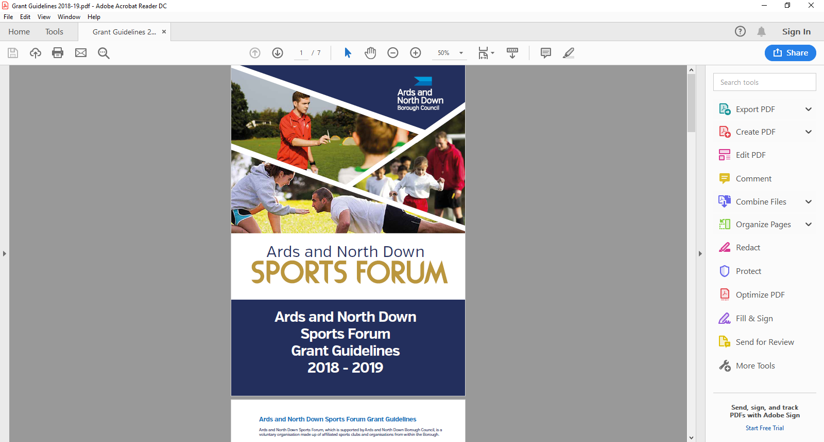

2025-2026

Individual

Travel / Accommodation

Guidance Notes

**Aim of Grant:**

The aim of the grant is to provide financial assistance to athletes within Ards and North Down and enable athletes to progress and compete at the highest level in their chosen sport.

**Funding Allocation**

Ards and North Down Sports Forum have allocated £28,000; the programme will remain open until the programme budget is fully exhausted. Should the programme be oversubscribed and due to limited funds available, a reduction in funding percentage will be applied to pending applications at that time.

**Application Timeline**

Individual Travel/ Accommodation grants are open all year round from 1 April 2025- 24 February 2026. Applications are assessed monthly by the Ards and North Down Sports Forum, please see deadline and assessment dates listed below:

|  |  |
| --- | --- |
| **Deadline for Receipt of Application Form** | **Assessment Date** |
| 25 March 2025 | 1 April 2025 |
| 29 April 2025 | 6 May 2025 |
| 27 May 2025 | 3 June 2025 |
| 24 June 2025 | 1 July 2025 |
| 29 July 2025 | 5 August 2025 |
| 26 August 2025 | 2 September 2025 |
| 30 September 2025 | 8 October 2025 |
| 28 October 2025 | 4 November 2025 |
| 25 November 2025 | 2 December 2025 |
| 30 December 2025 | 6 January 2026 |
| 27 January 2026 | 5 February 2026 |
| 24 February 2026 | 3 March 2026 |

**Incomplete applications, and applications received without the accompanying mandatory supporting documentation, will be deemed ineligible and not proceed for assessment.**

**Completed applications are to be submitted by email to** [**sportsdevelopment@ardsandnorthdown.gov.uk**](mailto:sportsdevelopment@ardsandnorthdown.gov.uk)

**Eligibility Criteria**

Assistance will be available for individuals who are representing their sport at a specific event at Provincial/ National/ International level. Applicants must:

* Be a resident of Ards and North Down Borough
* Take part in a sport affiliated to a National Governing Body recognised by Sport NI / Sport Ireland
* Be of amateur status.
* Qualified and selected to represent their province/country (i.e. Ulster, N. Ireland, Ireland or Great Britain).
* Provide specific event selection letter for the event from the relevant Sport NI/Sport Ireland **Recognised National Governing Body**\* (NGB) on official Governing Body headed paper or official Governing Body email statement.

To view the list of recognised NGB’s please click on links below;

[**https://www.sportni.net/Recognition-List**](https://www.sportni.net/Recognition-List)

[**https://www.sportireland.ie/Recognition-List**](https://www.sportireland.ie/Recognition-List)

Assistance may be considered (in exceptional circumstances) towards the costs

involved in attending National Governing Body Selection Training Squads.

Assistance may also be considered (in exceptional circumstances) from individuals who are residents of the Borough and who have been selected to compete at a High Standard competition/tournament. This will be at the discretion of the Forum and subject to available funds.

**Funding Limits**

Applicants may apply a **maximum of two times** (multiple events can be submitted on the one application but the events must be within 6 months of the application date) and there is a **£600 maximum** **limit** per athlete, **per financial year**. The minimum application amount is £100.

Assistance at a specific event/competition - up to a maximum:

|  |  |
| --- | --- |
| **Location of Event** | **Amount** |
| N. Ireland/Training Squad | £50 |
| Ireland - | £150 |
| Great Britain - | £200 |
| Mainland Europe | £250 |
| Outside of Europe | £300 |

Assistance towards costs involved in attending NGB Selection Training Squads, up to a maximum of £50, with a maximum of £200 towards NGB squads in a financial year.

**Please note:**

Travel Mileage calculated at 45 pence per mile, only applies within the island of Ireland and will only be considered for a minimum of 50 miles travel. Travel must commence from Northern Ireland.

**General Guidelines for Applicants**

Applications will be considered in line with the guidance outlined below.

* All applications must be completed in full, signed and submitted with all mandatory supporting information. Incomplete applications will not proceed for assessment, and **only typed forms** will be accepted.
* The application must be submitted **prior to competition commencing**.
* Successful applicants will be provided with a ‘Letter of Offer’, with specific deadlines to complete and return the report form, payee details and ‘Proof of Payment’ documents **(original receipts and bank statement). Failure to return documentation by the deadline will result in funding being withdrawn**

**What we will NOT fund:**

* Sports or projects for sports not listed by Sport NI/ Sport Ireland
* Sports or projects which are discriminating.
* Retrospective funding (except for pre-booked Travel/Accommodation costs) or costs incurred after the deadline for receipts.
* Applications received after the event commencing.
* Affiliation, entry fees to competitions or membership fees
* Entertainment costs, food and beverages
* Competitions where athletes are representing their school and have not qualified / been selected to represent their province/country.

The list above is not exhaustive. The Council reserves the right to fund/not fund any project which is deemed suitable/unsuitable for the Ards and North Down Sports Forum grant scheme.

**Post Application Process**

Following submission of applications, the following process will be completed:

All applications received will be acknowledged by email, within five working days of receiving.

**Application**

**Acknowledged**

Applications that fail to submit all required information will not proceed to the next stage.

**Mandatory Information Check**

**Sports Forum Assessment**

Applications considered in line with applicant eligibility/criteria.

**Notification of Award Decision**

Applicants will be informed about the outcome, following the Sports Forum Assessment.

.

**Application Forms**

Individual Travel and Accommodation guidance notes and application forms are available at: [Grants and Funding | AND Leisure (leisureardsandnorthdown.com)](https://eur01.safelinks.protection.outlook.com/?url=https%3A%2F%2Fwww.leisureardsandnorthdown.com%2Fsports-development%2Ffunding&data=05%7C01%7CChristine.Cooke%40ardsandnorthdown.gov.uk%7C20013338fac84358cd2c08db8eb5f28a%7C39416dee5c8e4f5cb59d05c4bd0dd472%7C0%7C0%7C638260684472085308%7CUnknown%7CTWFpbGZsb3d8eyJWIjoiMC4wLjAwMDAiLCJQIjoiV2luMzIiLCJBTiI6Ik1haWwiLCJXVCI6Mn0%3D%7C3000%7C%7C%7C&sdata=Udzx8Hm%2FNVmiv20dVccVfCjhvj0UoUbmEkUPz6D4Daw%3D&reserved=0) or by emailing [sportsdevelopment@ardsandnorthdown.gov.uk](mailto:sportsdevelopment@ardsandnorthdown.gov.uk)

**For queries contact the Sports Development Team**

**Email:** [sportsdeveloment@ardsandnorthdown.gov.uk](mailto:sportsdeveloment@ardsandnorthdown.gov.uk)

**Emma Wightman**, Assistant Sports and Recreation Development Officer

Tel: 0300 013 3333 ext. 40253 / 07972 660301