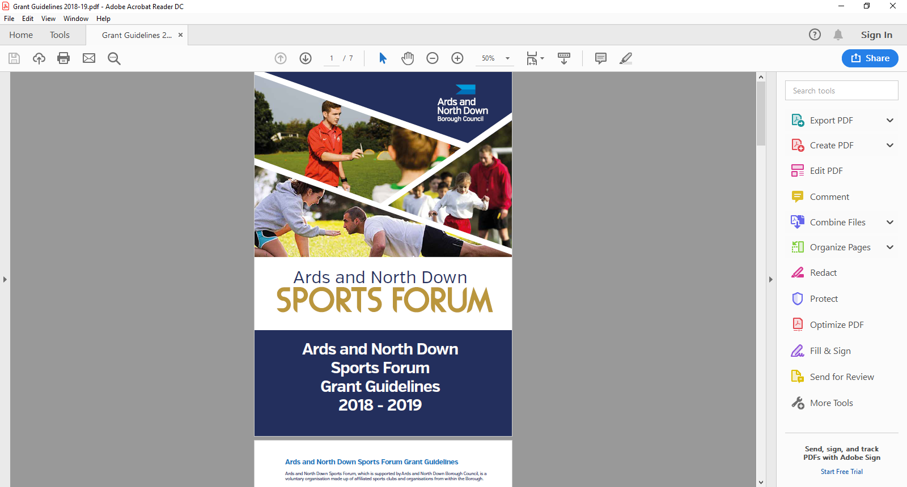

2025-2026

Individual

Travel / Accommodation

Application Form

(Individuals)

Individual Travel/Accommodation grants are open all year round from 1 April 2025 – 24 February 2026 and are assessed monthly by the Ards and North Down Sports Forum.

**Applicant Eligibility**

Assistance will be available for individuals who are representing their sport at a specific event at Provincial/ National/ International level. Applicants must:

* Be a resident of Ards and North Down Borough
* Take part in a sport affiliated to a National Governing Body recognised by Sport NI / Sport Ireland
* Be of amateur status.
* Qualified and selected to represent their province/country (i.e. Ulster, N. Ireland, Ireland or Great Britain).
* Provide specific event selection letter for the Event from the relevant **SNI/Sport Ireland Recognised National Governing Body** on official Governing Body headed paper or official Governing Body email statement. To view the list of recognised NGB’s please click on links below:

[**https://www.sportni.net/Recognition-List**](https://www.sportni.net/Recognition-List)

[**https://www.sportireland.ie/Recognition-List**](https://www.sportireland.ie/Recognition-List)

Assistance may be considered (in exceptional circumstances) towards the costs

involved in attending National Governing Body Selection Training Squads.

Assistance may also be considered (in exceptional circumstances) from individuals who are residents of the Borough and who have been selected to compete at a High Standard competition/tournament. This will be at the discretion of the Forum and subject to available funds.

**Funding Limits**

Applicants may apply a **maximum of two times** (multiple events can be submitted on the one application but the events must be within 6 months of the application date) and there is a **£600 maximum** **limit** per athlete, **per financial year**. The minimum application amount is £100.

Assistance at a specific event/competition - up to a maximum:

|  |  |
| --- | --- |
| **Location of Event** | **Amount** |
| N. Ireland/Training Squad | £50 |
| Ireland - | £150 |
| Great Britain - | £200 |
| Mainland Europe | £250 |
| Outside of Europe | £300 |

Assistance towards costs involved in attending NGB Selection Training Squads, up to a maximum of £50, with a maximum of £200 towards NGB squads in a financial year.

**Please note:**

Travel Mileage calculated at 45 pence per mile, only applies within the island of Ireland and will only be considered for a minimum of 50 miles travel. Travel must commence from Northern Ireland.

Should the Programme be oversubscribed and due to limited funds available, a reduction in funding percentage will be applied to pending applications at that time.

Please refer to **Guidance Notes** for a complete overview of grant guidelines, <https://www.leisureardsandnorthdown.com/sports-development/funding>

**ONLY APPLICATIONS COMPLETED IN A TYPED FORMAT CAN BE ACCEPTED.**

**Section 1 – Personal Details**

|  |  |
| --- | --- |
| Name |  |
| Date of Birth |  |
| Address | Postcode |
| Name for Correspondence | *(Please complete if different than applicant or applicant is under 18)* |
| Contact Email |  |
| Contact Number |  |

**Section 2 – Sport / Event Details**

|  |  |
| --- | --- |
| Sport |  |
| Club |  |
| Recognised Governing Body | *(Please refer to links *)* |

**\***[**https://www.sportni.net/Recognition-List**](https://www.sportni.net/Recognition-List)

**\***[**https://www.sportireland.ie/Recognition-List**](https://www.sportireland.ie/Recognition-List)

|  |  |
| --- | --- |
| Event 1 |  |
| Date of Event |  |
| Venue/Location |  |
| Representative level |  |

|  |  |
| --- | --- |
| Event 2 |  |
| Date of Event |  |
| Venue/Location |  |
| Representative level |  |

|  |  |
| --- | --- |
| Event 3 |  |
| Date of Event |  |
| Venue/Location |  |
| Representative level |  |

**Section 3 – Travel/ Accommodation Details**

|  |  |  |  |  |
| --- | --- | --- | --- | --- |
| **Fuel Costs -** ***Fuel costs only apply to travel within Island of Ireland.***  (Minimum of 50 miles travel, calculated at 45p/mile)  ***Please retain receipts and bank statements for verification purposes, for each cost incurred.*** | | | | |
| **From** | | **To** | **Miles** | **Cost** |
| Event 1 | |  |  | £ |
| Event 2 | |  |  | £ |
| Event 3 | |  |  |  |
|  | |  | **Total** | **£** |
| **Transport Costs** | | | | |
| **Type - Plane/Ferry etc.** | | **From** | **To** | **Cost** |
| Event 1 | |  |  | £ |
| Event 2 | |  |  | £ |
| Event 3 | |  |  | £ |
|  | | | **Total** | **£** |
| **Accommodation Costs** | | | | |
| **Date(s) From** | **Date(s) To** | **Name of Hotel/B&B etc** | **Location** | **Cost** |
| Event 1 |  |  |  | £ |
| Event 2 |  |  |  | £ |
| Event 3 |  |  |  | £ |
|  | | | **Total** | **£** |
| **Total Travel Costs incured** | | | | **£** |
| **Total funding being requested** | | | | **£** |

**Section 4 – Funding**

|  |  |  |
| --- | --- | --- |
| Are you receiving funding assistance from any other source for this financial year? (Please tick) | | |
| Yes | No |  |
| If yes, please provide information below | | |
| Name of organisation/ funding body providing assistance | Nature of Assistance  e.g. amount of funding | Duration of Assistance  E.g. one off payment, 3 year agreement |
|  |  |  |
| Are you receiving funding assistance from any other source for this/these events? (Please tick) | | |
| Yes | No |  |
| If yes, please provide information below | | |
| Name of organisation/ funding body providing assistance | Nature of Assistance  e.g. amount of funding | Duration of Assistance  E.g. one off payment |
|  |  |  |

**Section 5 – Document Checklist**

**Please ensure the following documents are attached to your application**

|  |  |
| --- | --- |
| **Mandatory Documents required** | **Attached (Please tick)** |
| Completed Application |  |
| Letter of selection/qualification from Governing Body on GB Headed paper or official GB email statement |  |

**Incomplete applications, and applications received without the accompanying mandatory supporting documentation, will be deemed ineligible and not proceed for assessment.**

**DATA PROTECTION.**

Ards and North Down Borough Council is the data controller for the purposes of the Data Protection Act 2018 and the UK GDPR, which means it determines what your personal data is used for and why it is collected. We will only collect your data for the purposes of this application and retained for a period of up to 7years for financial reasons in line with Council’s retention and disposal policy.

We will not share your data with any third party unless it is required for legal reasons.

Your personal data is yours. You have the right to get copies of the information we hold about you.

If you want to request information regarding your data, please email: The Data Protection Officer: [dataprotection@ardsandnorthdown.gov.uk](mailto:dataprotection@ardsandnorthdown.gov.uk)

**FREEDOM OF INFORMATION.**

Under the Freedom of Information Act 2000 (FOIA), individuals have a right to request access to the information held by a public body. This can include grant applications.

Under the FOIA we are not obliged to release the personal information of individuals unless they consent to this release.

Consequently, Ards and North Down Borough Council will not disclose sensitive personal data to anyone else without the individuals express consent. Additionally, we will seek permission from the individual or organisation who submitted the application for their views about its release in the event of a request for this information.

**What do you do if you are unhappy with how we have handled your information?**

It is also your right to complain about our use of your data to the Information Commissioners Office, who are our regulator, but please contact us first to try and resolve any issues.

[Access the full privacy notice here.](https://www.ardsandnorthdown.gov.uk/privacy-and-cookies)

**Section 6 – Declaration**

|  |
| --- |
| I declare to the best of my knowledge the information provided within this application is correct.  I declare I am of amateur status and have qualified/been selected to represent my sport at a national/international level.  I declare that I will complete a Grant Report Form after my event and will acknowledge the funders in all publicity.  I declare that the Council will be notified immediately of any additional finding not declared in this application.  It is understood that monies will only be paid out on the production of all receipts.  Any grant funding deemed ineligible or not spent will be re-payable to Ards and North Down Borough Council. |

Signed:_______________________________________ Date: ______________

(to be signed by parent/guardian for applicant if under 18years)

Once completed, please email the application along with the required documentation to the following address:

**[sportsdevelopment@ardsandnorthdown.gov.uk](\\\\ardsandnorthdown.gov.uk\\Fileshare\\C&W\\Leisure and Amenities\\Leisure\\Sports Development\\Projects\\Funding - Funded Projects\\ANDBC Sports Forum\\Grant Scheme and Application Forms\\2024-2025\\DRAFT Application Forms\\sportsdevelopment@ardsandnorthdown.gov.uk)**