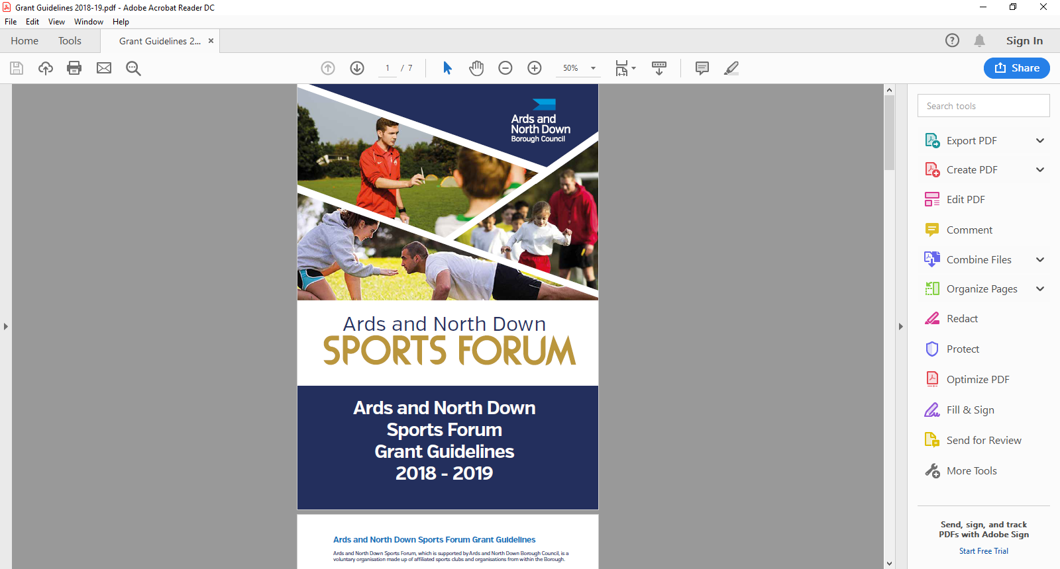

2025-2026

Goldcard

Guidance Notes

**Aim of Grant**

The Goldcard grant is to support athletes who have qualified and are **training for a specific event and/or competition,** by providing concessionary use of leisure facilities within the Ards and North Down Borough

**Facilities include:**

* Ards Blair Mayne Wellbeing and Leisure Complex
* Bangor Aurora Aquatic and Leisure Complex
* Bangor Sportsplex
* Comber Leisure Centre
* Londonderry Park
* Portaferry Sports Centre
* Queen’s Leisure Complex, Holywood.

Athletes can avail of the following within the Goldcard scheme:

* Gym Facilities
* Swimming Pools
* Health Suite
* Cryo-Spa at Londonderry Park
* Sports Specific facilities e.g. the track at Bangor Sportsplex.

**Application Timeline**

Goldcard grants are open all year round from 1 April 2025- 24 February 2026. Applications are assessed monthly by the Ards and North Down Sports Forum, please see deadline and assessment dates listed below:

|  |  |
| --- | --- |
| **Deadline for Receipt of Application Form** | **Assessment Date** |
| 25 March 2025 | 1 April 2025 |
| 29 April 2025 | 6 May 2025 |
| 27 May 2025 | 3 June 2025 |
| 24 June 2025 | 1 July 2025 |
| 29 July 2025 | 5 August 2025 |
| 26 August 2025 | 2 September 2025 |
| 30 September 2025 | 8 October 2025 |
| 28 October 2025 | 4 November 2025 |
| 25 November 2025 | 2 December 2025 |
| 30 December 2025 | 6 January 2026 |
| 27 January 2026 | 5 February 2026 |
| 24 February 2026 | 3 March 2026 |

**Incomplete applications, and applications received without the accompanying mandatory supporting documentation, will be deemed ineligible and not proceed for assessment. Completed applications are to be submitted by email to** [**sportsdevelopment@ardsandnorthdown.gov.uk**](mailto:sportsdevelopment@ardsandnorthdown.gov.uk)

**Eligibility Criteria**

* Applicants must be12 years, at the time of application.
* Be a resident in the Ards and North Down Borough Council area
* Take part in a Sport affiliated to a National Governing Body (NGB) recognised by Sport NI/Sport Ireland
* Be of amateur status
* Be a member of a recognised elite squad or be ranked within the top 10 in Northern Ireland / Ireland (Elite squad/panel e.g. Ulster, Northern Ireland, Ireland, Great Britain, European and above). This will cover Junior and Senior athletes and be inclusive of those with a disability.
* Be qualified and selected to represent their province/country (i.e. Ulster, N. Ireland, Ireland or Great Britain).
* Provide specific event selection letter for the event from the relevant Sport NI/Sport Ireland **Recognised National Governing Body** (NGB) on official Governing Body headed paper or official Governing Body email statement.

To view the list of recognised NGB’s please click on links below;

[**https://www.sportni.net/Recognition-List**](https://www.sportni.net/Recognition-List)

[**https://www.sportireland.ie/Recognition-List**](https://www.sportireland.ie/Recognition-List)

* The letter/email must verify that you are part of a recognised squad or an Individual in preparation for a specific event/competition.
* The Governing Body letter/email **MUST** state what event/competition details you are preparing for and when the final squad will be announced, if applicable.
* The event/competition must be within 12 months of application being made.
* Not be in receipt of lottery or any other grant that would cover the facility element of training costs.

**The extent of use to be at the discretion of the Head of Leisure.**

**Duration of GoldCard**

* Goldcards will ONLY be granted if the event/competition exceeds more than 2 months from the date of application submission to a maximum of 12 months.
* If selected for multiple events, or part of a recognised squad preparing for events, Goldcards will be issued for the last event listed, if it is detailed on the National Governing Body Selection Letter/Email.

**Restrictions**

Please note applicants should be aware that there are restrictions in place at each facility according to the individual site’s admissions policy, including:

* The Health Suite is for 16+ at Bangor Aurora and 8-15’s must be accompanied by an Adult at Ards Blair Mayne.
* There are ‘restrictions’ for use of the Gym for under 16’s and **inductions must be completed.**
* Swimming Pool restrictions apply
* Cryospa restrictions apply.
* **Usage of facilities will be subject to availability at the time.**

For further information please visit:

[Admissions Policy | AND Leisure (leisureardsandnorthdown.com)](https://eur01.safelinks.protection.outlook.com/?url=https%3A%2F%2Fleisureardsandnorthdown.com%2Fadmissions-policy&data=05%7C02%7CChristine.Cooke%40ardsandnorthdown.gov.uk%7C1aac5d73d39b454b088708dc1c2b85f0%7C39416dee5c8e4f5cb59d05c4bd0dd472%7C0%7C0%7C638416220450590124%7CUnknown%7CTWFpbGZsb3d8eyJWIjoiMC4wLjAwMDAiLCJQIjoiV2luMzIiLCJBTiI6Ik1haWwiLCJXVCI6Mn0%3D%7C3000%7C%7C%7C&sdata=E9ejR9AX9rRPMcVE5Dwr8YYWloxtIaC80JvbNEiQuZk%3D&reserved=0)

[Northern Community Leisure Trust (bangoraurora.com)](https://eur01.safelinks.protection.outlook.com/?url=https%3A%2F%2Fwww.bangoraurora.com%2Fpolicies-documents%2F&data=05%7C02%7CChristine.Cooke%40ardsandnorthdown.gov.uk%7C53dc4aab95784da4b31108dc27ea72b4%7C39416dee5c8e4f5cb59d05c4bd0dd472%7C0%7C0%7C638429135152145696%7CUnknown%7CTWFpbGZsb3d8eyJWIjoiMC4wLjAwMDAiLCJQIjoiV2luMzIiLCJBTiI6Ik1haWwiLCJXVCI6Mn0%3D%7C0%7C%7C%7C&sdata=d6vqksIs%2B5oQi5Q5QueNrYRBBC1HmGCyRpiUos4y1ic%3D&reserved=0)

[https://www.leisureardsandnorthdown.com/CryospaAdmissionsPolicy](https://www.leisureardsandnorthdown.com/sites/default/files/2019-06/Cryospa%20Admissions%20Policy.pdf)

**Application Process**

Successful applicants will be provided with a link to the App, or be provided with an appropriate membership card, that must be used on each visit to a Leisure facility.

Please note that successful applicants may be requested by the Council to attend the promotion of specific sports events/ schemes during the lifespan of the Goldcard.

**ONLY APPLICATIONS COMPLETED IN A TYPED FORMAT CAN BE ACCEPTED.**

**Post Application Process**

Following submission of applications, the following process will be completed:

**Application**

**Acknowledged**

All applications received will be acknowledged by email, within five working days of receiving.

Applications that fail to submit all required information will not proceed to the next stage.

**Mandatory Information Check**

**Sports Forum Assessment**

**Consideration of Application**

Applications considered in line with applicant eligibility/criteria.

Applicants will be informed about the outcome, following the Sports Forum Assessment.

.

**Notification of Award Decision**

**Notification of Award Decision**

Notification to applicants will be issued following the Sports Forum review.

**Application Forms**

Goldcard guidance notes and applications are available at:

[Grants and Funding | AND Leisure (leisureardsandnorthdown.com)](https://eur01.safelinks.protection.outlook.com/?url=https%3A%2F%2Fwww.leisureardsandnorthdown.com%2Fsports-development%2Ffunding&data=05%7C01%7CChristine.Cooke%40ardsandnorthdown.gov.uk%7C20013338fac84358cd2c08db8eb5f28a%7C39416dee5c8e4f5cb59d05c4bd0dd472%7C0%7C0%7C638260684472085308%7CUnknown%7CTWFpbGZsb3d8eyJWIjoiMC4wLjAwMDAiLCJQIjoiV2luMzIiLCJBTiI6Ik1haWwiLCJXVCI6Mn0%3D%7C3000%7C%7C%7C&sdata=Udzx8Hm%2FNVmiv20dVccVfCjhvj0UoUbmEkUPz6D4Daw%3D&reserved=0) or by emailing [sportsdevelopment@ardsandnorthdown.gov.uk](mailto:sportsdevelopment@ardsandnorthdown.gov.uk)

**For queries contact the Sports Development Team**

**Email:** [sportsdeveloment@ardsandnorthdown.gov.uk](mailto:sportsdeveloment@ardsandnorthdown.gov.uk)

**Emma Wightman**, Assistant Sports and Recreation Development Officer

Tel: 0300 013 3333 ext. 40253 / 07972 660301