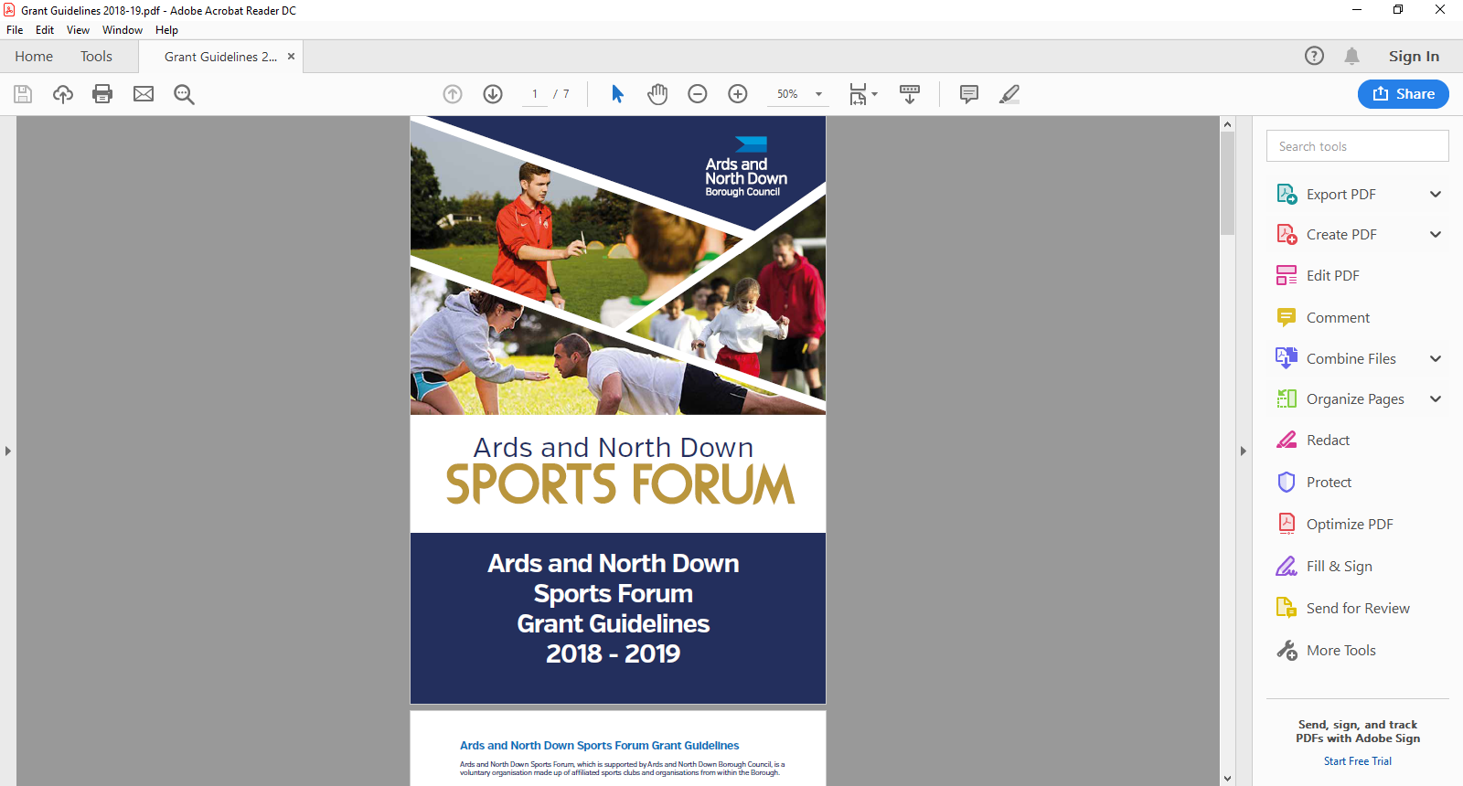

2025-2026

Coach Education

Guidance Notes

**Applicant Eligibility**

**Aim of Grant**

The coach education grant is to provide financial assistance to affiliated sport clubs to increase the number of National Governing Body (NGB) qualified coaches and officials, and to support the delivery of continuous professional development (CPD) for coaches, officials and volunteers within the Borough of Ards and North Down.

Sports Club can apply for financial assistance towards the following.

* National Governing Body (NGB) sports specific coaching qualifications.
* National Governing Body (NGB) officiating qualifications.
* To deliver club development training/workshops for example:
  + - Sport NI Safeguarding Young People and Children Workshop.
    - Sport Specific First Aid
    - Disability Inclusion Awareness Workshop.
* To attend continuing professional development (CPD)
* To attend specialist coaching conferences/workshops to advance their knowledge of their chosen sport. (speaker/coach must have suitable Governing Body and/or Awarding Body qualifications).

**Funding Allocation**

Ards and North Down Sports Forum have allocated **£3,000;** the programme will remain open until the programme budget is fully exhausted. Should the programme be oversubscribed and due to limited funds available, a reduction in funding percentage will be applied to pending applications at that time. **Max grant available per sport club per financial year is £500.**

**Application Timeline**

Coach education grants are open all year round from 1 April 2025 – 24 February 2026. Applications are assessed monthly by the Ards and North Down Sports Forum.

All completed applications must be submitted prior to the deadline dates below along with essential documents. Submit completed applications to email: [**sportsdevelopment@ardsandnorthdown.gov.uk**](mailto:sportsdevelopment@ardsandnorthdown.gov.uk)

|  |  |
| --- | --- |
| **Deadline for Receipt of Application Form** | **Assessment Date** |
| 25 March 2025 | 1 April 2025 |
| 29 April 2025 | 6 May 2025 |
| 27 May 2025 | 3 June 2025 |
| 24 June 2025 | 1 July 2025 |
| 29 July 2025 | 5 August 2025 |
| 26 August 2025 | 2 September 2025 |
| 30 September 2025 | 8 October 2025 |
| 28 October 2025 | 4 November 2025 |
| 25 November 2025 | 2 December 2025 |
| 30 December 2025 | 6 January 2026 |
| 27 January 2026 | 5 February 2026 |
| 24 February 2026 | 3 March 2026 |

**Incomplete applications, and applications received without the accompanying mandatory supporting documentation, will be deemed ineligible and not proceed for assessment.**

**Eligibility Criteria**

Applicants (Sport Club) must meet the following eligibility requirements;

* Affiliated to the Ards and North Down Sports Forum and newly affiliated clubs must be outside the 3-month waiting period.
* The applicant (sport club) must provide sporting activities recognised by Sport Northern Ireland through the Sport NI/Sport Ireland recognition policy and be affiliated to a recognised governing body.
* The sports qualification/officials course must be recognised by their national governing body of sport.
* Training workshops must be delivered by a recognised training provider
* Courses **MUST** be booked prior to submitting application (course confirmation is required to be submitted along with application)
* Application must be submitted prior to the start of the coaching course.
* Have an Equality Policy
* Have adequate public liability insurance (propose only request to see PLI if they are delivering a course within their club)?

**Funding Limits**

* Specialist coaching provided by an external qualified coach – up to 75% and a maximum of £150
* National governing body sport qualifications – up to 75% of costs and a maximum of £300
* Qualification courses for Officials – up to a 75% of costs and a maximum of £150
* Club development training/workshops - up to 75% of costs up to a maximum of £200.
* Attending CPD Workshops – up to 75% of registration fee up to a maximum of £200.

**General Guidelines for Applicants**

Applications will be considered in line with the guidance below:

* All applications must be completed in full, signed and submitted with all the mandatory supporting information. Incomplete applications will not proceed for assessment, and only typed forms will be accepted.
* Changes to the expenditure or nature of the project **MUST** be approved by the Sports Development Officer before the Club proceeds.
* All expenditure must be within the financial year.
* Successful applicants will be provided with a ‘Letter of Offer’ and a specific deadline to return ‘Proof of Payment’ documents **(original receipts and club bank statement****). Failure to return documentation by the deadline will result in funding being withdrawn**

**What we will NOT fund:**

* Projects, events, activities undertaken or equipment purchased outside of the specified award period.
* Projects, events, and activities where the primary benefits outside of the Borough.
* Events, projects or activities which conflict with any Council run project, event or activity.
* Organisations not legally established in the UK
* Projects, events, activities not compliant with the Council’s aims and objectives
* Sports or projects for sports not listed by Sport Northern Ireland / Sport Ireland
* Organisations that do not have a Safeguarding Children and Vulnerable Adults policy.
* Retrospective funding (except for pre-booked Coaching costs) or costs that will be incurred after the deadline for receipts.
* Coaching Costs which have not been booked.
* Access NI registration fees
* Organisation’s own facility hire – groups cannot be paid for use of own venue.
* VAT that can be recovered from HM Revenue and Customs

This list above is not exhaustive. The Council reserves the right to fund/not fund any project which is deemed suitable/ unsuitable for the Ards and North Down Sports Forum grant scheme.

**Post Application Process**

Following submission of applications, the following process will be completed:

All applications received will be acknowledged by email, within five working days of receiving.

**Application**

**Acknowledged**

**Mandatory Information Check**

Applications that fail to submit all required information will not proceed to the next stage.

Applications considered in line with applicant eligibility/criteria.

**Sports Forum Assessment**

**Consideration of Application**

**Notification of Award Decision**

Applicants will be informed about the outcome, following the Sports Forum Assessment.

.

**Applications Forms**

Coach Education guidance notes and application forms are available at:

[Grants and Funding | AND Leisure (leisureardsandnorthdown.com)](https://eur01.safelinks.protection.outlook.com/?url=https%3A%2F%2Fwww.leisureardsandnorthdown.com%2Fsports-development%2Ffunding&data=05%7C01%7CChristine.Cooke%40ardsandnorthdown.gov.uk%7C20013338fac84358cd2c08db8eb5f28a%7C39416dee5c8e4f5cb59d05c4bd0dd472%7C0%7C0%7C638260684472085308%7CUnknown%7CTWFpbGZsb3d8eyJWIjoiMC4wLjAwMDAiLCJQIjoiV2luMzIiLCJBTiI6Ik1haWwiLCJXVCI6Mn0%3D%7C3000%7C%7C%7C&sdata=Udzx8Hm%2FNVmiv20dVccVfCjhvj0UoUbmEkUPz6D4Daw%3D&reserved=0) or by emailing [sportsdevelopment@ardsandnorthdown.gov.uk](mailto:sportsdevelopment@ardsandnorthdown.gov.uk)

For queries contact the Sports Development Team.

**Email:** [sportsdevelopment@ardsandnorthdown.gov.uk](mailto:sportsdevelopment@ardsandnorthdown.gov.uk)

**Emma Wightman**, Assistant Sports and Recreation Development Officer

Tel: 0300 013 3333 ext. 40253 / 07972 660301