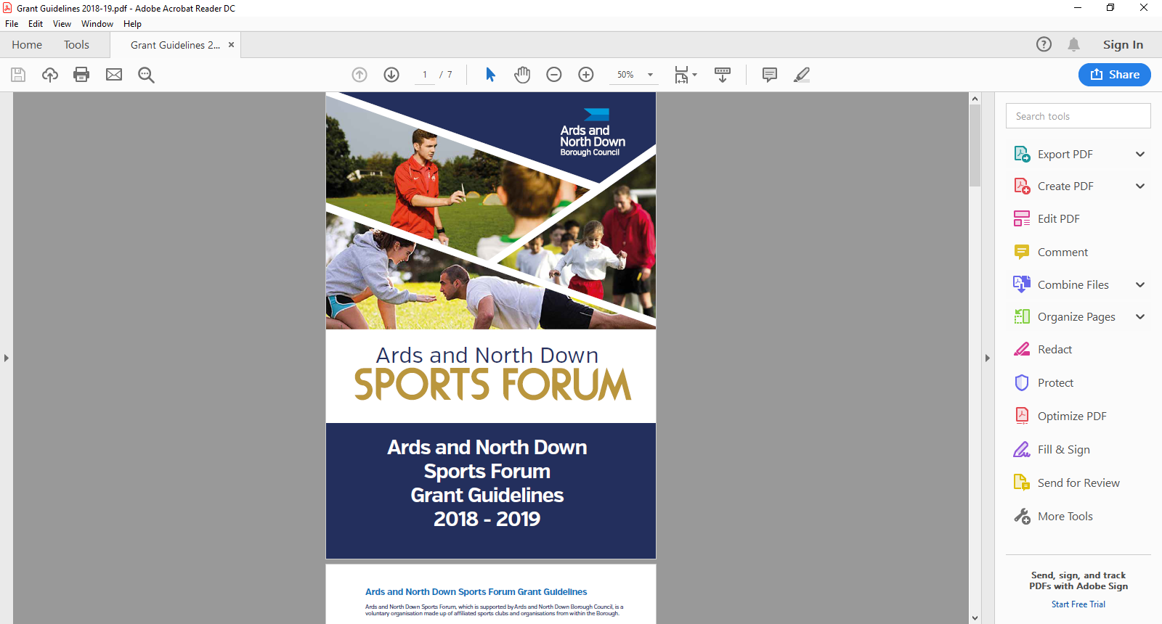

2025-2026

Coach Education

Application Form

**Applicant Eligibility**

Sport clubs can apply for financial assistance towards the cost of coaches attending National Governing Body, officials’ courses and CPD workshops

**Funding Limits**

1. Specialist coaching provided by an external qualified coach – up to 75% and a maximum of £150
2. Governing body sports coach qualification – up to 75% of costs and a maximum of £300
3. Qualification courses for Officials – up to a 75% of costs and a maximum of £150
4. Training/ Workshops

* Organising club development training/workshops (e.g. SNI Safeguarding young people and children, Sport Specific First Aid, disability inclusion training by Disability Sport NI) - up to 75% of costs up to a maximum of £200.
* Attending CPD Workshops – up to 75% of registration fee up to a maximum of £200

**The maximum funding per club for Coaching/Training Grants is £500 per financial year.**

**Application Timeline**

Coach education grants are open all year round from 1 April 2025 – 24 February 2026. Applications are assessed monthly by the Ards and North Down Sports Forum.

|  |  |
| --- | --- |
| **Deadline for Receipt of Application Form** | **Assessment Date** |
| 25 March 2025 | 1 April 2025 |
| 29 April 2025 | 6 May 2025 |
| 27 May 2025 | 3 June 2025 |
| 24 June 2025 | 1 July 2025 |
| 29 July 2025 | 5 August 2025 |
| 26 August 2025 | 2 September 2025 |
| 30 September 2025 | 8 October 2025 |
| 28 October 2025 | 4 November 2025 |
| 25 November 2025 | 2 December 2025 |
| 30 December 2025 | 6 January 2026 |
| 27 January 2026 | 5 February 2026 |
| 24 February 2026 | 3 March 2026 |

*Please refer to **guidance notes as incomplete application will not be accepted. Guidance Notes are available at the link below:**

<https://www.leisureardsandnorthdown.com/sports-development/funding>

Please submit applications to[**sportsdevelopment@ardsandnorthdown.gov.uk**](mailto:sportsdevelopment@ardsandnorthdown.gov.uk)

**ONLY APPLICATIONS COMPLETED IN A TYPED FORMAT CAN BE ACCEPTED.**

**Section 1 - Club/Organisational Details**

|  |  |
| --- | --- |
| Name of Club/ Organisation |  |
| Sport |  |
| Governing Body |  |
| Contact Name |  |
| Role/Position within Club/ Organisation |  |
| Contact Number |  |
| Contact Email |  |
| Address for Correspondence |  |
| Ards and North Down Sports Forum 2025/26  Reference Number |  |

**Section 2 – Coaching Details**

|  |  |  |
| --- | --- | --- |
| Please tick which coaching grant are you applying for?  (**one application per category ticked**) | Coaching qualifications |  |
| Officials qualifications |  |
| External Specialist Coaching |  |
| CPD/Specialist Coaching conferences/workshop |  |
| Club development/ training workshop |  |
| Describe what your club/organisation is applying for and who will be delivering course/training/ coaching. | (Please note name and level of course) | |
| Outline start and finish dates of course/ training/ coaching events. |  | |
| Detail how your club/organisation will benefit. |  | |

**Section 3 - Funding Details**

|  |  |  |  |  |  |  |
| --- | --- | --- | --- | --- | --- | --- |
| Project breakdown/Coaching itemised | Net Costs  (excluding VAT) | VAT Costs | | Total project costs | | Amount requested from funding |
|  | £ | £ | | £ | | £ |
|  | **£** | £ | | £ | | £ |
|  | **£** | £ | | £ | | £ |
|  | **£** | £ | | £ | | £ |
|  | **£** | £ | | £ | | £ |
|  | **£** | £ | | £ | | £ |
| **Total Costs** | **£** | **£** | | **£** | | **£** |
| If the total costs are higher than the requested amount of funding or higher than the maximum available, outline where the balance of the funding is coming from? |  | | | | | |
| Is your club/organisation VAT registered? | | | Yes | | No | |
| If yes, what is your VAT registration number? | | |  | | | |
| Does your club / organisation intend to claim VAT back if successful? | | | Yes | | No | |

**Section 4 – Any additional information**

Please provide any additional information which you feel is relevant to your application.

|  |
| --- |
|  |

**Section 5 – Document Checklist**

Please ensure the following documents are attached to your application.

|  |  |  |
| --- | --- | --- |
| **Mandatory Document required.** |  | **Attached** |
| Sport Club Constitution (dated &signed) | **Essential** |  |
| Club Minute – approving coaches to attend courses/ workshop to be delivered/ attended | **Essential** |  |
| List of Office bearers and role | **Essential** |  |
| Club/Organisation Safeguarding Children and/or Vulnerable Adult Policy (must have been reviewed and signed & dated within the past 3 years) | **Essential** |  |
| If a Club is adopting the National Governing Body Safeguarding Policy, the Club must provide written confirmation of this and provide details of Designated Safeguarding Officers. | **Essential** |  |
| Club/Organisation Equality Policy | **Essential** |  |
| Confirmation of places allocated on course/workshop booked | **Essential** |  |

**Incomplete applications, applications received without the accompanying mandatory supporting documentation, will be deemed ineligible and not proceed for assessment.**

**DATA PROTECTION.**

Ards and North Down Borough Council is the data controller for the purposes of the Data Protection Act 2018 and the UK GDPR, which means it determines what your personal data is used for and why it is collected. We will only collect your data for the purposes of this application and retained for a period of up to 7 years for financial reasons in line with Council’s retention and disposal policy.

We will not share your data with any third party unless it is required for legal reasons.

Your personal data is yours. You have the right to get copies of the information we hold about you.

If you want to request information regarding your data, please email: The Data Protection Officer: [dataprotection@ardsandnorthdown.gov.uk](mailto:dataprotection@ardsandnorthdown.gov.uk)

**FREEDOM OF INFORMATION.**

Under the Freedom of Information Act 2000 (FOIA), individuals have a right to request access to the information held by a public body. This can include grant applications.

Under the FOIA we are not obliged to release the personal information of individuals unless they consent to this release.

Consequently, Ards and North Down Borough Council will not disclose sensitive personal data to anyone else without the individuals express consent. Additionally, we will seek permission from the individual or organisation who submitted the application for their views about its release in the event of a request for this information.

**What do you do if you are unhappy with how we have handled your information?**

It is also your right to complain about our use of your data to the Information Commissioners Office, who are our regulator, but please contact us first to try and resolve any issues.

[Access the full privacy notice here.](https://www.ardsandnorthdown.gov.uk/privacy-and-cookies)

**Section 6 – Declaration**

This must be signed by the Chairperson of the organisation alongside another Club Member and dated accordingly.

|  |
| --- |
| I declare that the information provided is correct to the best of my knowledge.  I agree to promote equality and good relations in all our activities involving the use of Council funding in accordance with Section 75 of the Northern Ireland Act 1998.  I declare that I will complete a Grant Report Form and will acknowledge the funders in all publicity.  I declare that the Council will be notified immediately of any additional findings not declared in this application.  It is understood that monies will only be paid out on the production of all, receipts.  Any grant funding deemed ineligible or not spent will be re-payable to Ards and North Down Borough Council. |

|  |  |  |
| --- | --- | --- |
|  | **Chairperson** | **Club Member** (Position in Organisation) |
| Signed |  |  |
| Name  (Please print) |  |  |
| Date |  |  |

Once completed, please email the application along with the required documentation to the following address:

**[sportsdevelopment@ardsandnorthdown.gov.uk](\\\\ardsandnorthdown.gov.uk\\Fileshare\\C&W\\Leisure and Amenities\\Leisure\\Sports Development\\Projects\\Funding - Funded Projects\\ANDBC Sports Forum\\Grant Scheme and Application Forms\\2024-2025\\DRAFT Application Forms\\sportsdevelopment@ardsandnorthdown.gov.uk)**